SOAPUI/REST SERVICES

1. **What is web service?**

A web service is a collection of open protocols and standards used for exchanging data between applications or systems. Software applications written in various programming languages and running on various platforms can use web services to exchange data over computer networks like the Internet in a manner similar to inter-process communication on a single computer.

Web services are client and server applications that communicate over the World Wide Web’s (WWW) HyperText Transfer Protocol (HTTP).

**2) What is XML and what will be the format?**

XML is a file extension for an Extensible Markup Language (XML) file format used to create common information formats and share both the format and the data on the World Wide Web, intranets, and elsewhere using standard ASCII text.

XML is similar to HTML. Both XML and HTML contain markup symbols to describe the contents of a page or file. HTML, however, describes the content of a Web page (mainly text and graphic images) only in terms of how it is to be displayed and interacted with. For example, the letter "p" placed within markup tags starts a new paragraph.

Format of XML:

<note>  
  <to>Teacher</to>  
  <from>Student</from>  
  <heading>Wishes</heading>  
  <body>Good morning and have a good day</body>  
</note>

**3) What is requestxml and responseXML**

All modern browsers have a built-in XMLHttpRequest object to request data from a server.

All major browsers have a built-in XML parser to access and manipulate XML.

The XMLHttpRequest Object can be used to request data from a web server.

The XMLHttpRequest object is **a developers dream**, because you can:

* Update a web page without reloading the page
* Request data from a server - after the page has loaded
* Receive data from a server  - after the page has loaded
* Send data to a server - in the background

**4) Different http methods?**

 POST, GET, PUT, PATCH, and DELETE

**5) What is json and how is the format look like?**

**JSON** (JavaScript Object Notation) is a minimal, readable format for structuring data. It is used primarily storing and exchanging data or to transmit data between a server and web application, as an alternative to XML, easier-to-use

**Format:**

{"employees":[  
    {"firstName":"John", "lastName":"Doe"},  
    {"firstName":"Anna", "lastName":"Smith"},  
    {"firstName":"Peter", "lastName":"Jones"}  
]}

**6) Difference is soap web service and rest web service**

|  |  |
| --- | --- |
| SOAP | REST |
| SOAP stands for Simple Object Access Protocol. | REST stands for Representational State Transfer. |
| SOAP is a XML based messaging protocol. | REST is not a protocol but an architectural style. |
| SOAP has a standard specification. | REST has no standard specification. |
| Even SOAP based web services can be implemented in RESTful style. | REST is a concept that does not tie with any protocols. |
| SOAP is distributed computing style. | REST is web style (web is also a distributed computing model). |
| SOAP is XML based message protocol. | REST does not enforces message format as XML or JSON. |
| SOAP has specifications for stateful implementation. | REST follows stateless model. |
| SOAP is strongly typed, has strict specification for every part of implementation. | REST gives the concept and less restrictive about the implementation. |
| SOAP uses interfaces and named operations to expose business logic. | REST uses (generally) URI and methods like (GET, PUT, POST, DELETE) to expose resources. |

*Soapui Screen where the request is run for a project

Footballinfo (project) 🡪 InfoSoapBinding12 (TestSuite) 🡪 AllGames (TestCase) 🡪 Request 1(soap)

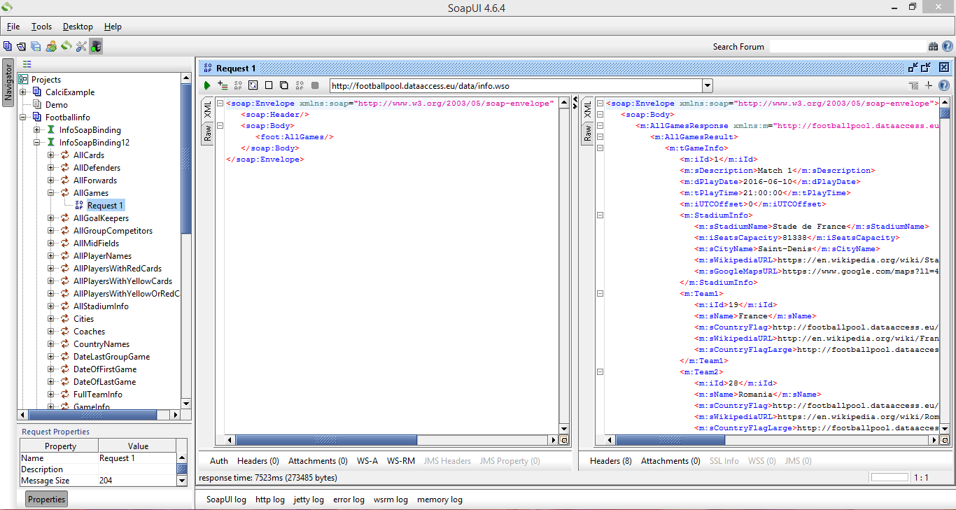

**7) Assertions in soapUI**

Assertion means act of affirming or stating something. It can also be interpreted as check once a request is sent to a web server a response is received. We need to validate if the response contains the data that we expect. In order to validate the response, we need to use assertions.

Types of assertions are:

* Property content
* Compliance status standard
* Script
* SLA
* JMS
* Security

*Adding Assertions:

Click on the + (plus) symbol on the request screen.

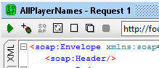

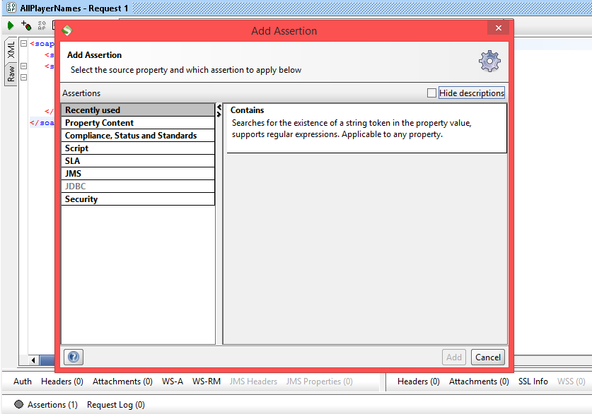*Add Assertion screen will pop-up

**\***Select Property Content 🡪 Contains section [To check if the response contains the property value or token]

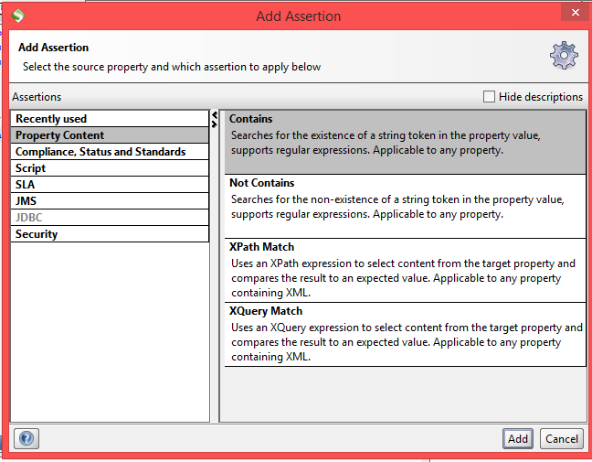

*Contains Assertion window pops-up when click on Add on “Add Assertion” window

Type the string/value of the property to check the response and then click on OK.

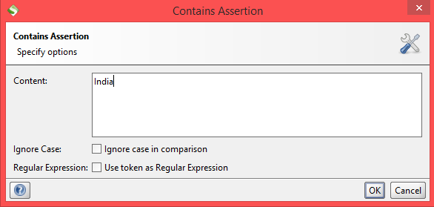

**\***Check the Assertions on the bottom left side. The SOAP Response is displayed with the result. [VALID/ FAILED]

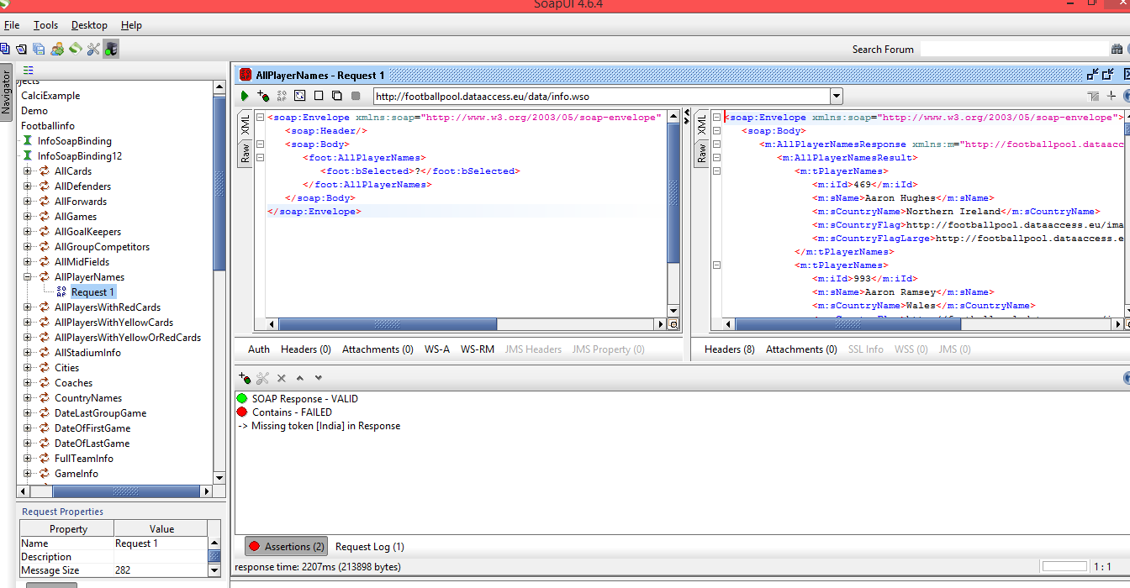

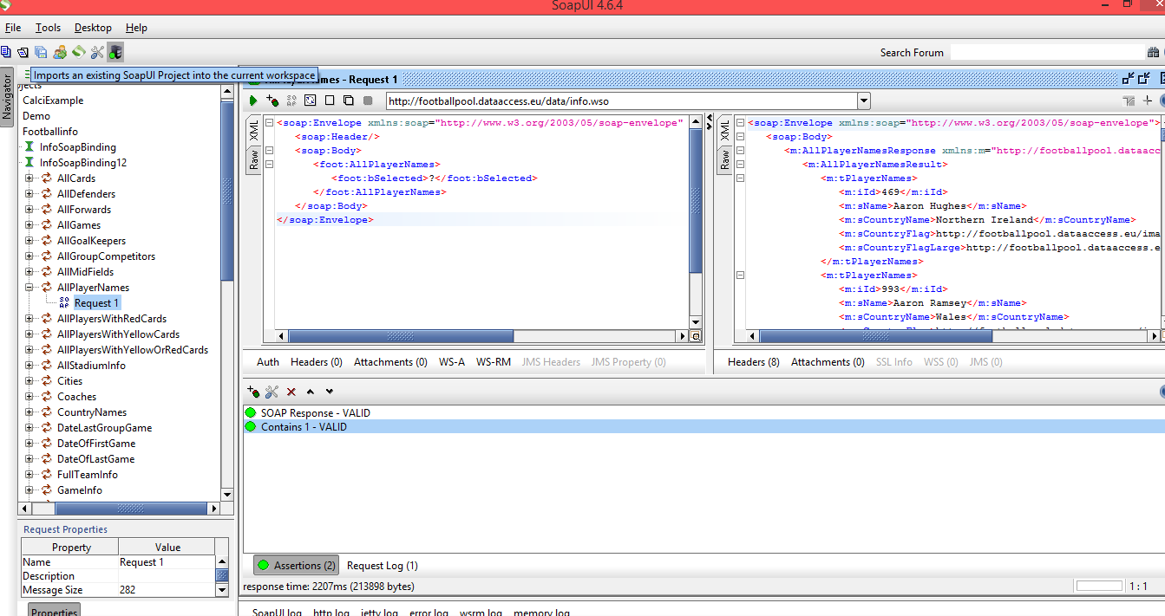

**8) What is / and // in xpath?**

/: Selects from the root node.

//: Selects nodes in the document from the current node that match the selection no matter where they are.

**9) How to read attributes in xpath**

After you have figured how to select an element in your XML document, just take it one step further to get the attribute.

At the end of your XPath expression, which is normally the element you want to select, add at sign “@” plus the name of the attribute you wish to select. The following XPath expression selects chips element.

**10) Different functions in xpath (contains(), text() etc)**

### number last()

### number position()

### number count(node-set)

### node-set id(object)

### string local-name(node-set?)

### string string(object?)

### string concat(string, string, string*)

### string starts-with(string, string)

### string contains(string, string)

**11) What are endpoint and operation names?**

WSDL is an XML format for describing network services as a set of endpoints operating on messages containing either document-oriented or procedure-oriented information. The operations and messages are described abstractly, and then bound to a concrete network protocol and message format to define an endpoint. Related concrete endpoints are combined into abstract endpoints (services).

WSDL is extensible to allow description of endpoints and their messages regardless of what message formats or network protocols are used to communicate, however, the only bindings described in this document describe how to use WSDL in conjunction with SOAP 1.1, HTTP GET/POST, and MIME.

**MySql Workbench Deploy Code using Local Server:**

1. Axis2servr.batch file:

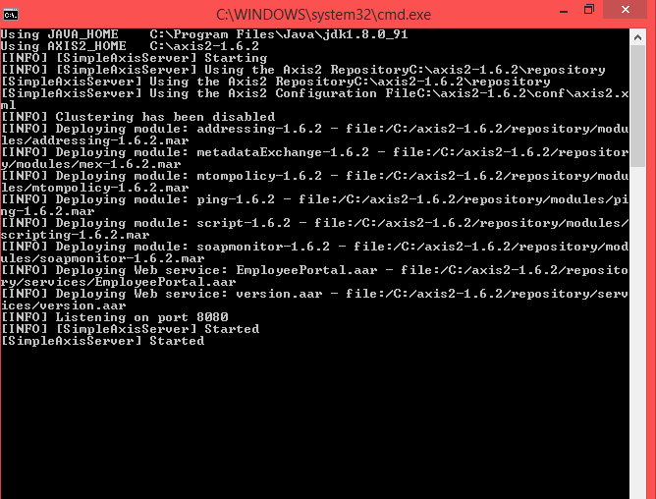

1. LOCALHOST AXIS2 :SERVICES PAGE:

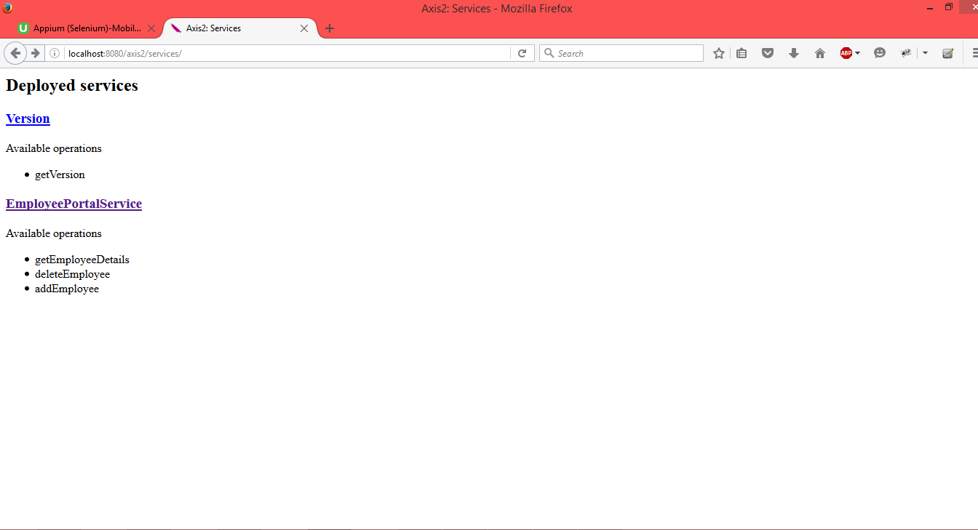

1. MySql Workbench :

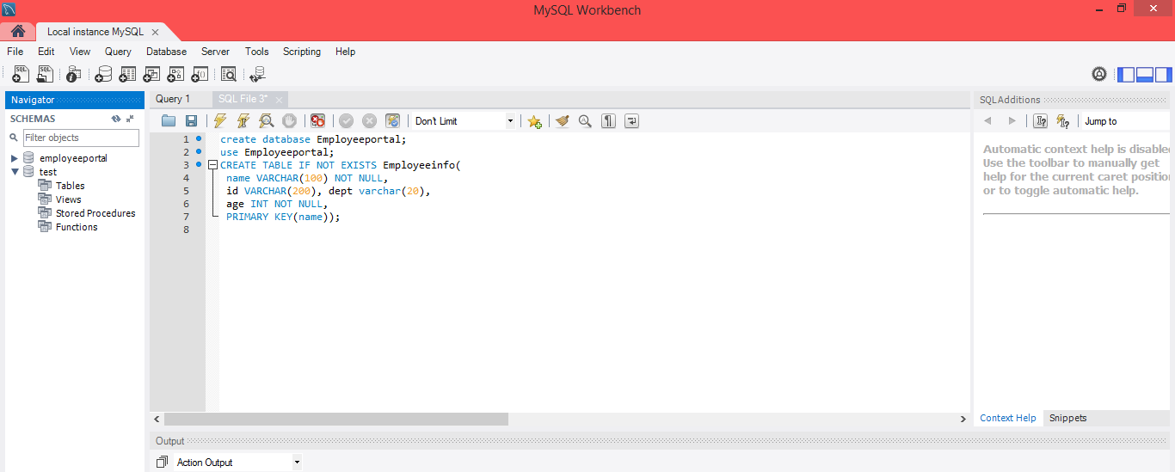

1. Version page:

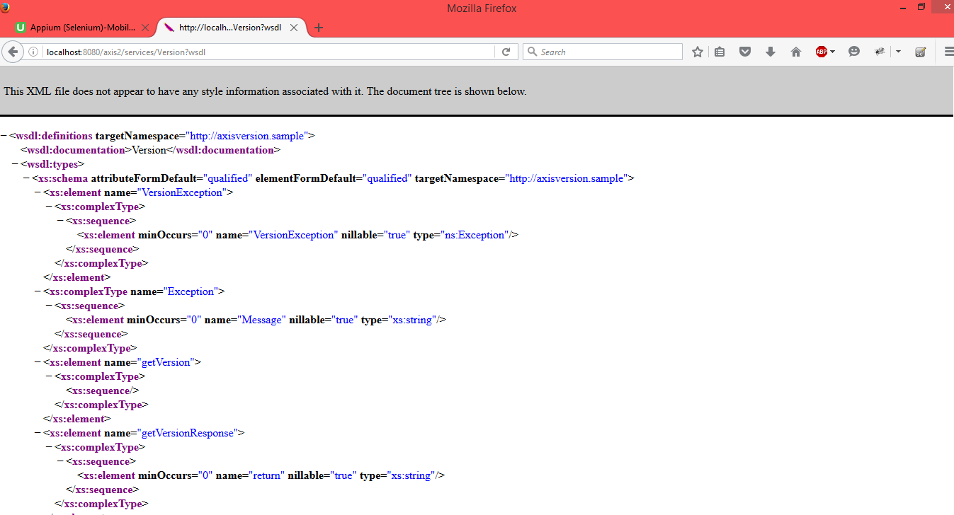

1. EmployeePortalService Page:

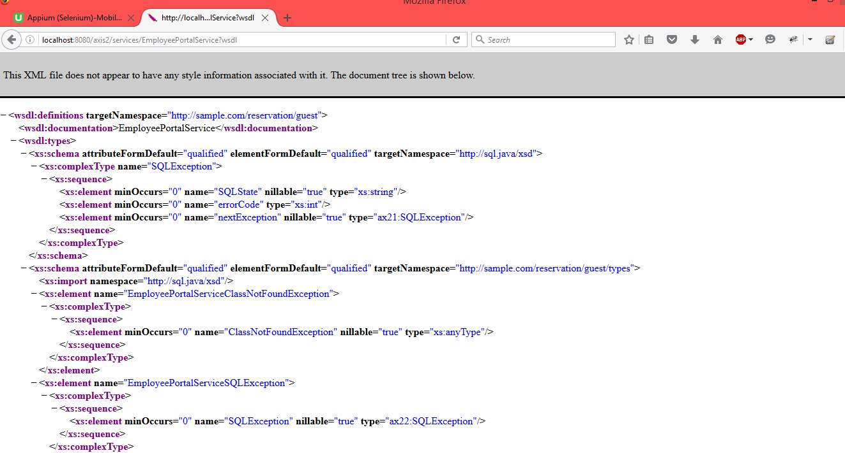

Click on file and Create a new soapui project

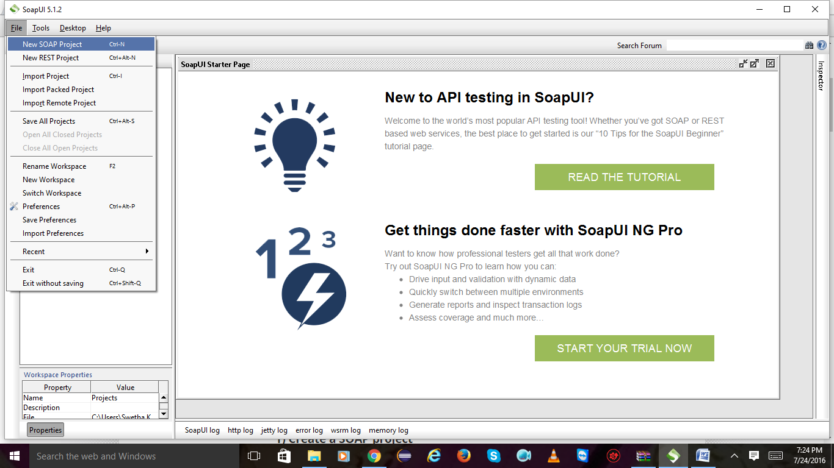

2) give project name and url and click on ok.

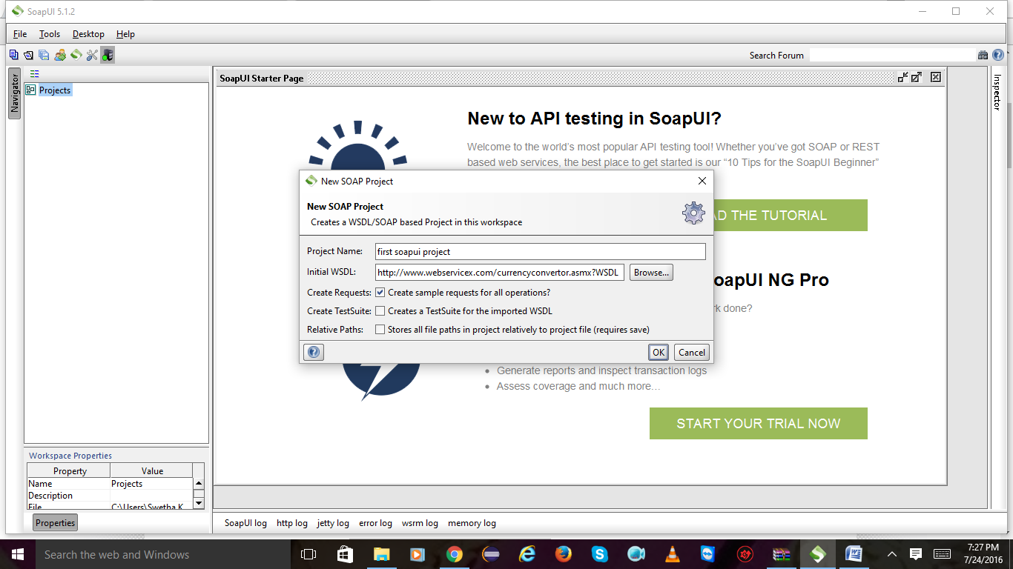

4) I have created a new project and adding a new test case for request

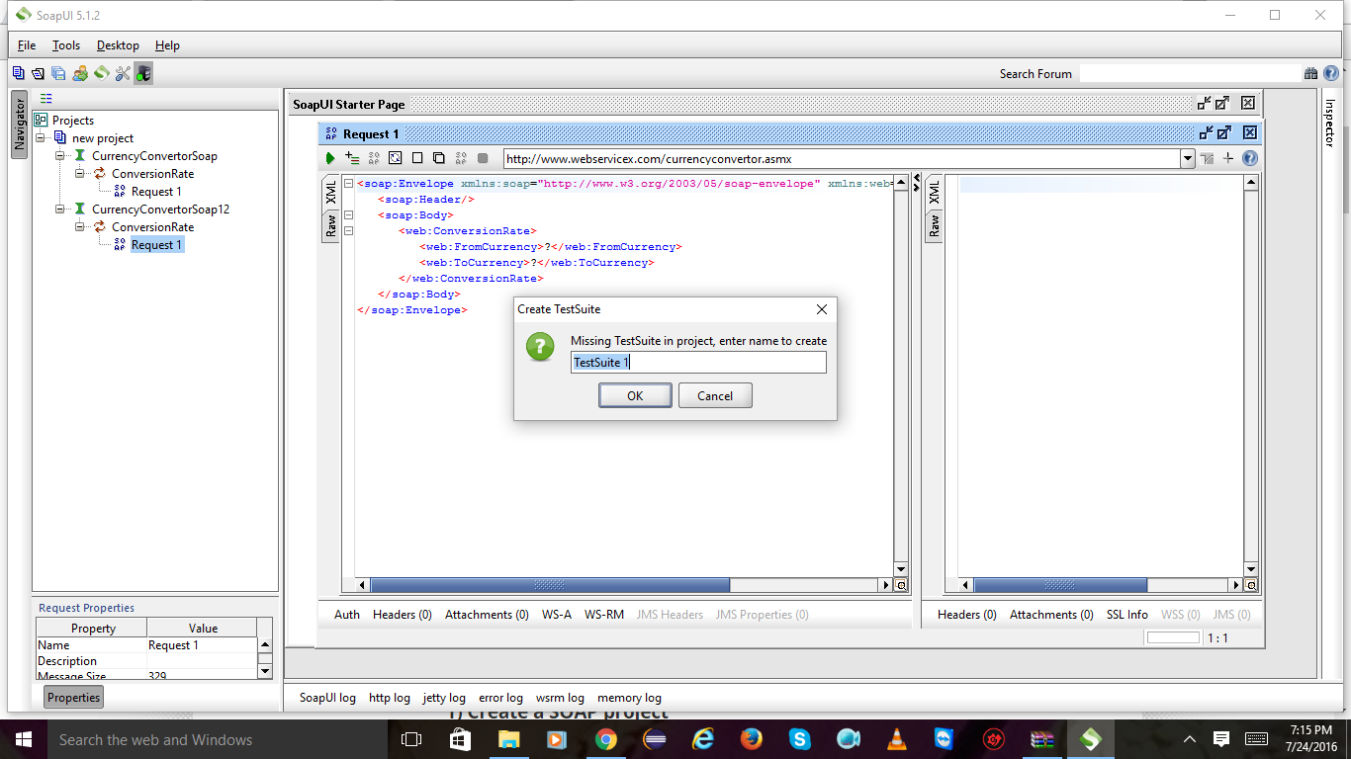

Click ok on test case

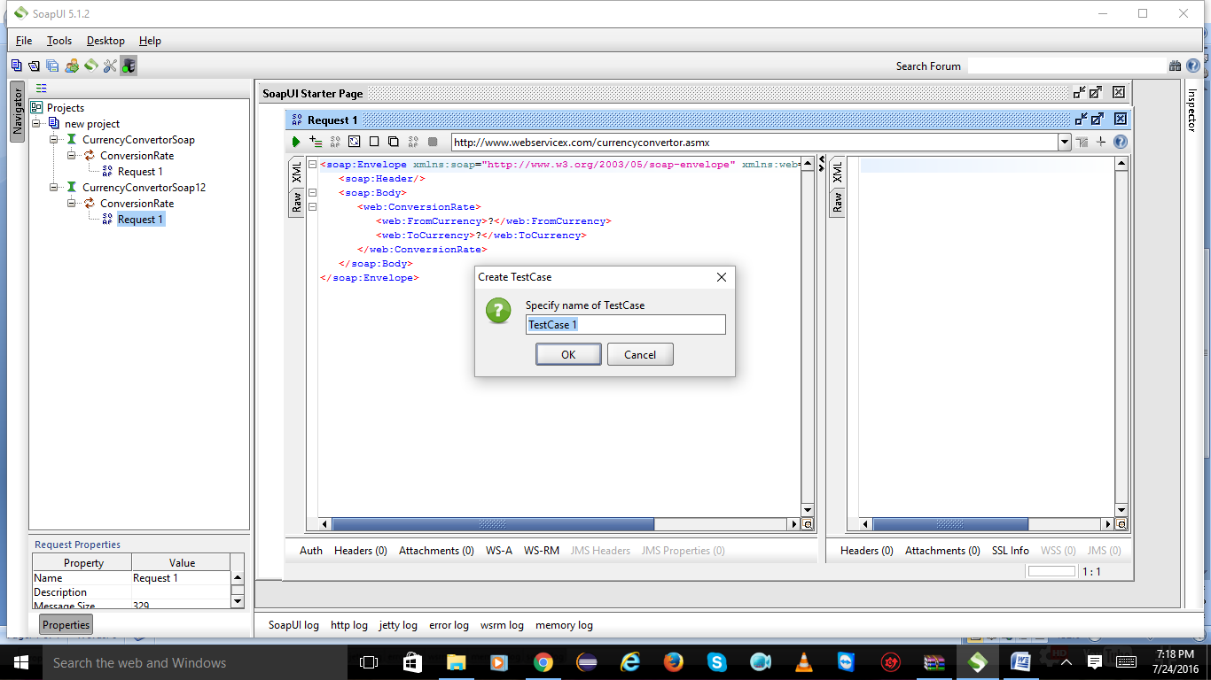

Click on ok

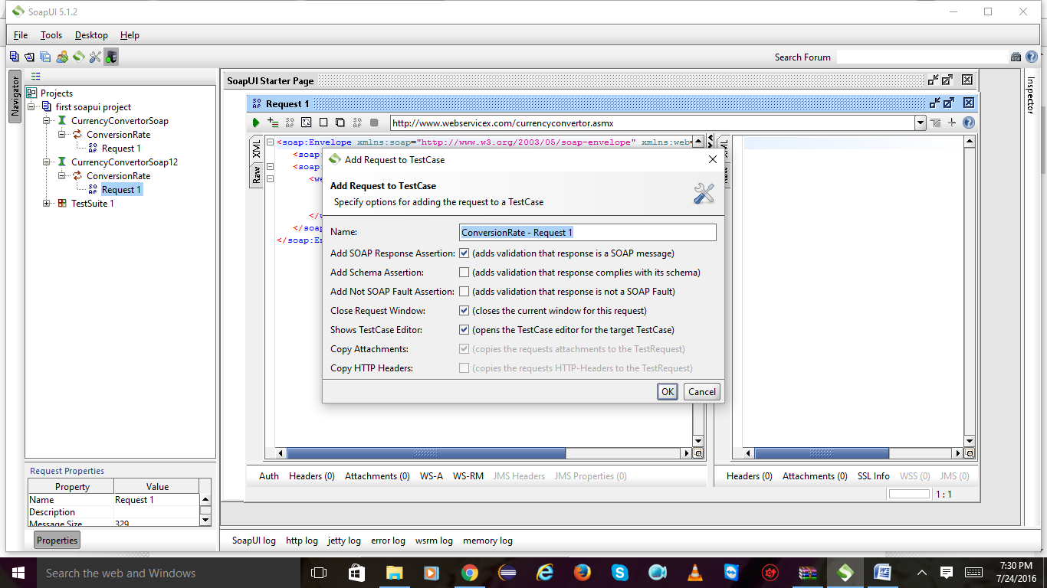

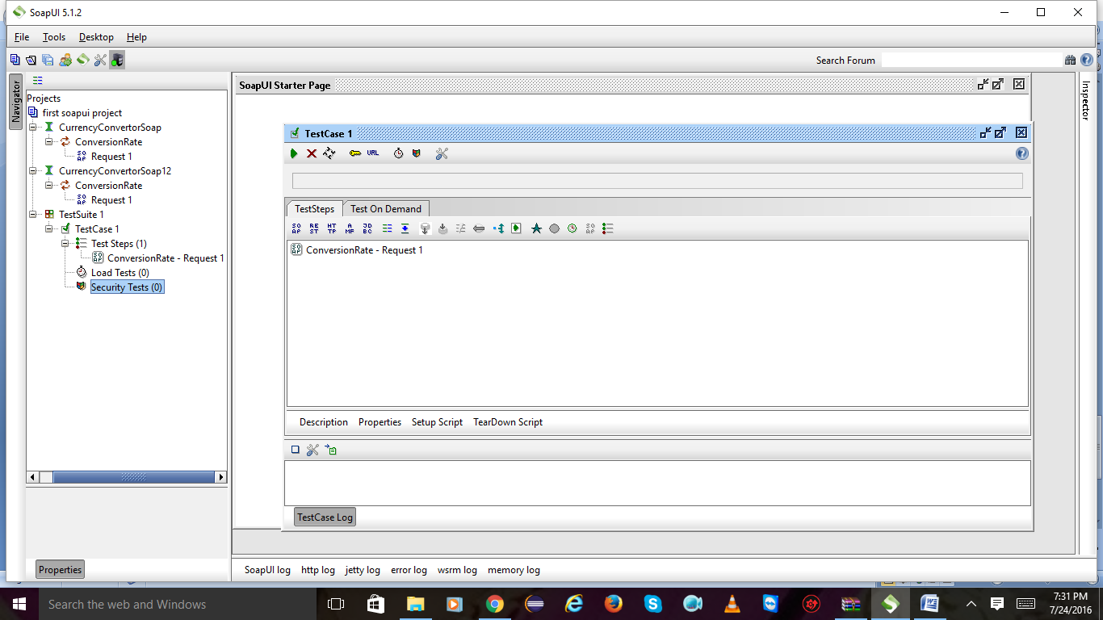

Click on assertion and click on icon left side and mark on hide description u will get 4 options select xpath match and click on add.

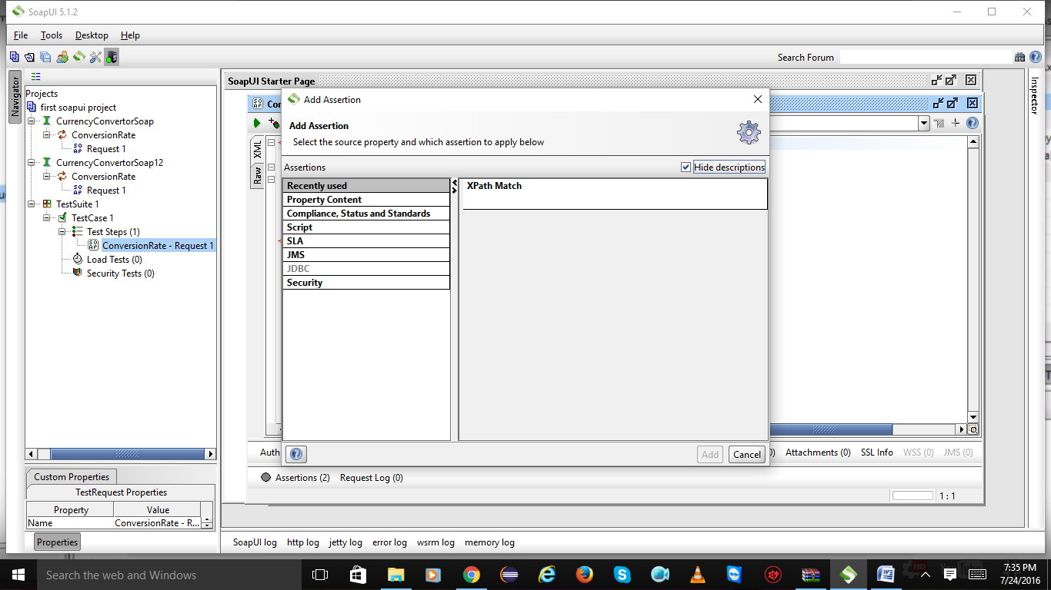

Click on ok

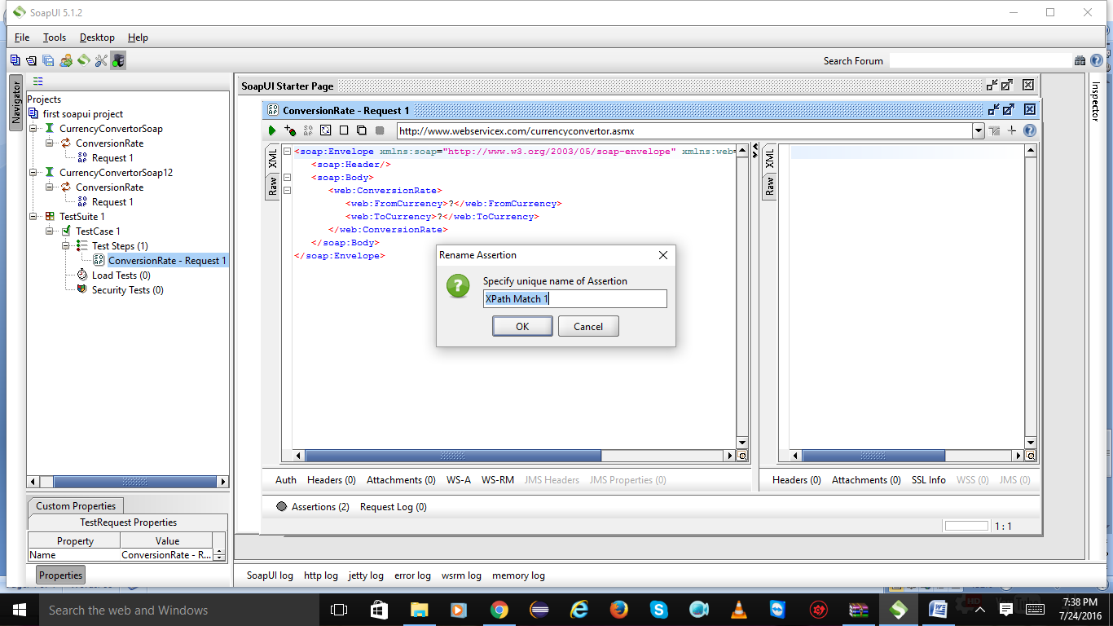

Click on declare u will get namespace to be add or not click on yes and save

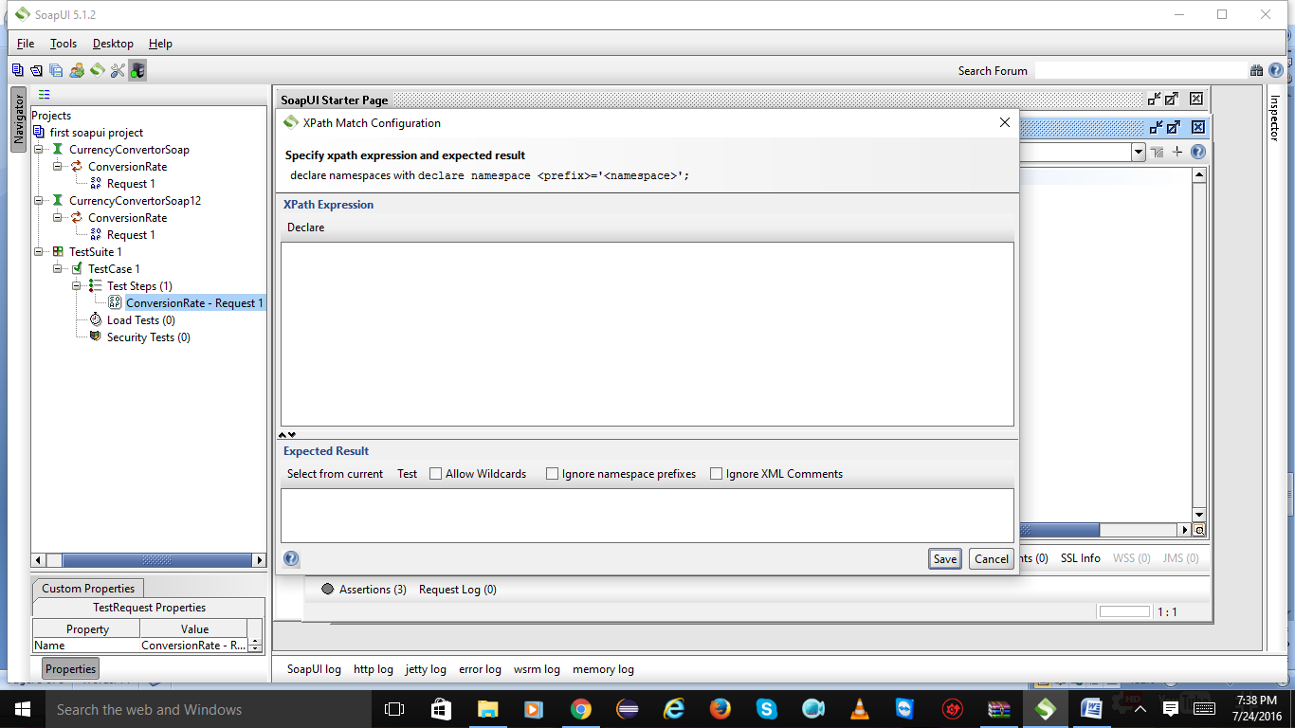

After saving choose

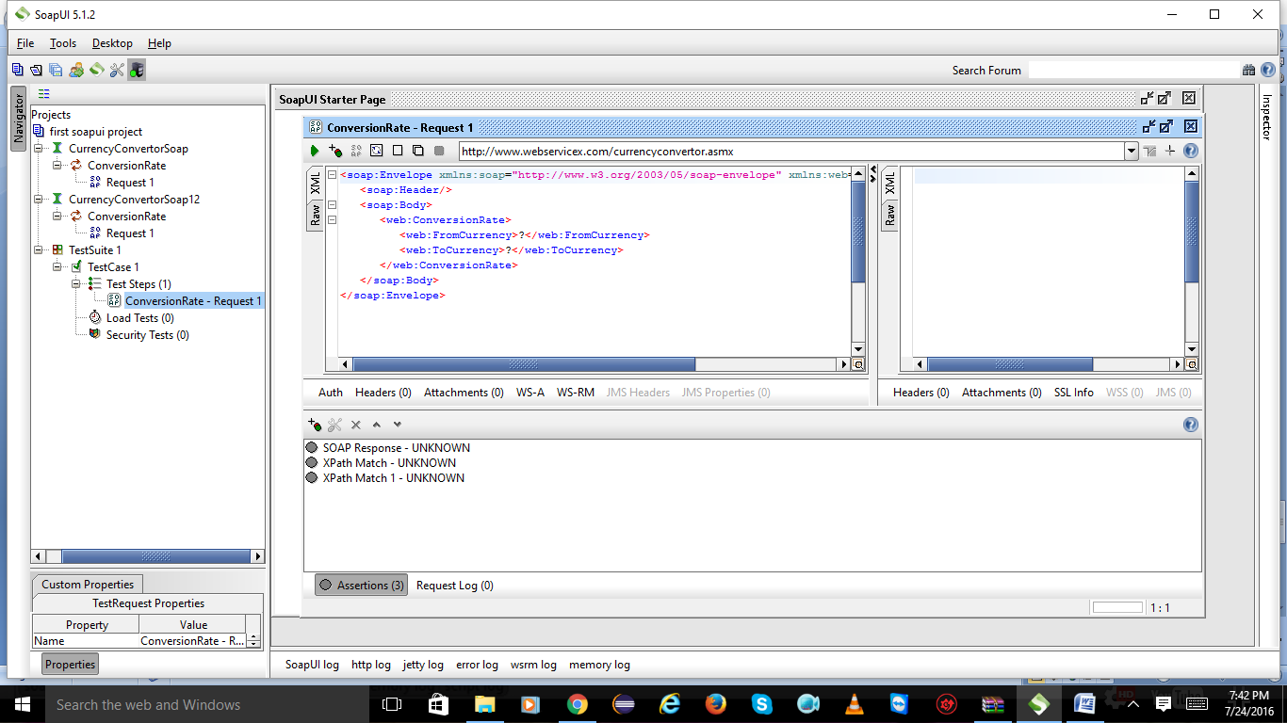

Click on test suite 1

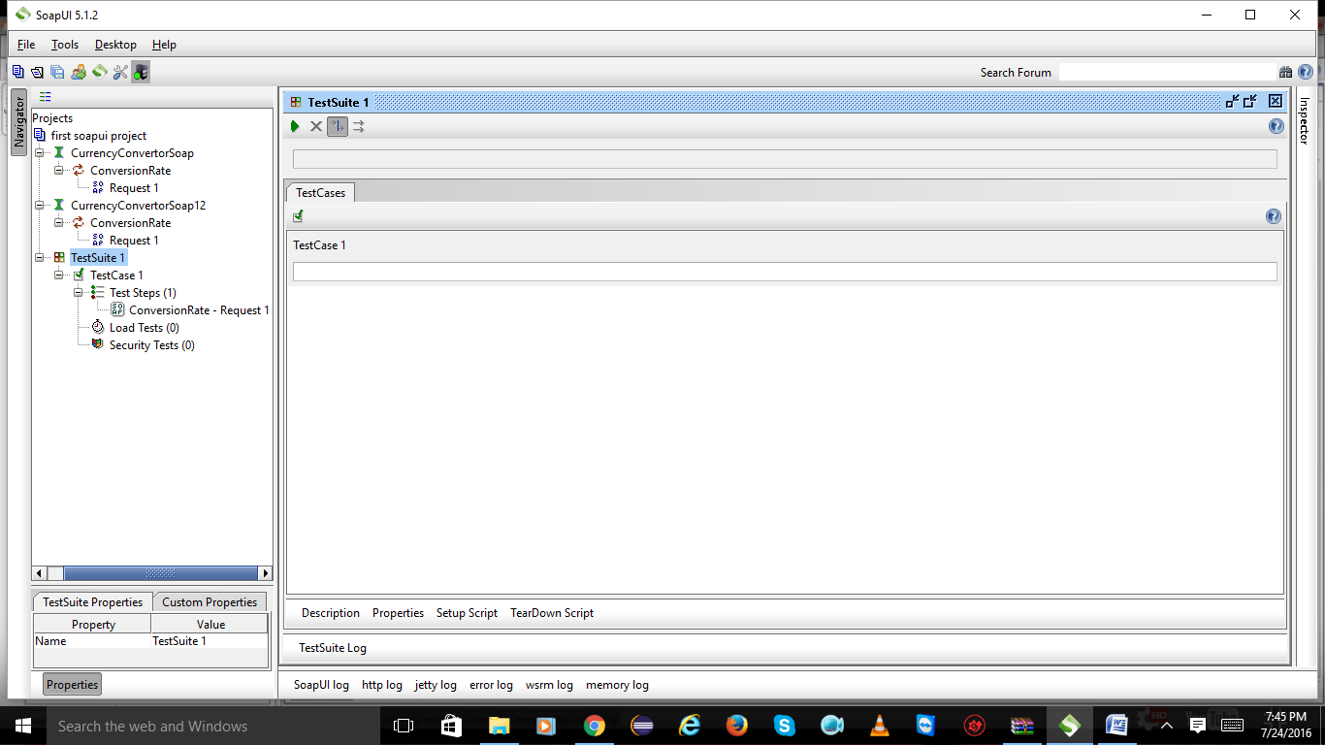

**Assertions:**

**Basic assertions:**

Add test case:

verify response returning true:

verify assertion not having null or false value:

verify response is valid soap response-soap assertion:

verify response have valid HTTP code:

verify that response time is with in boundaries:

verify security threat:

Right click on test suite and select new test case

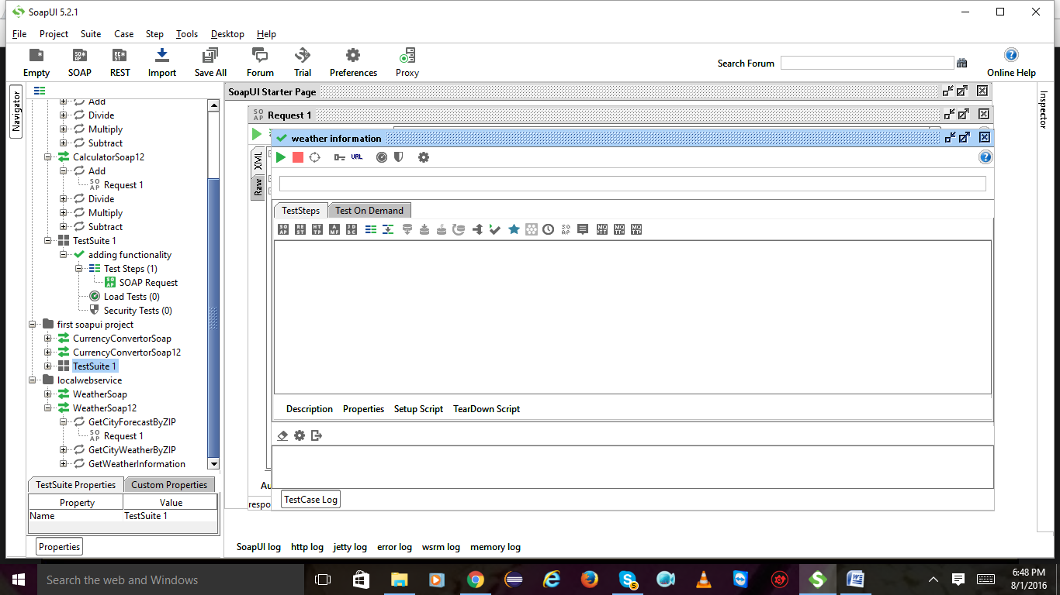

Expand test suite and also test case right on it and select add step in that again select soap request

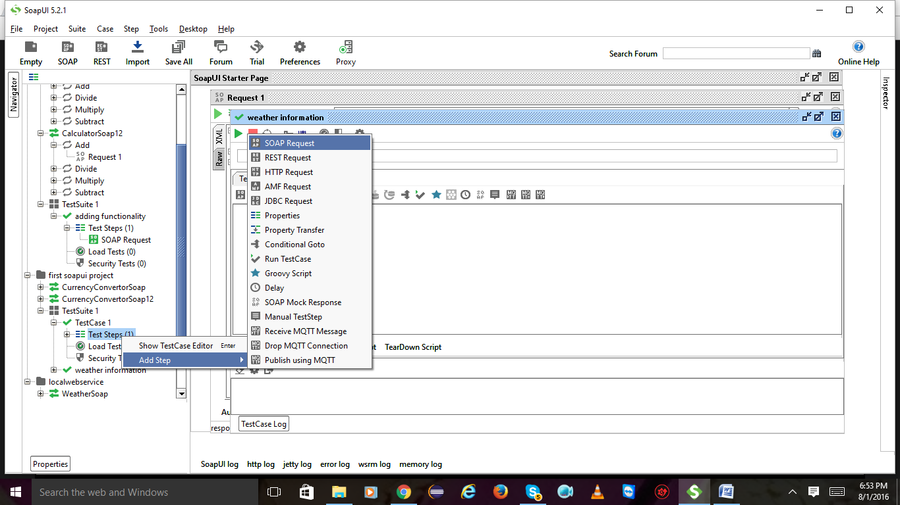

Click on ok

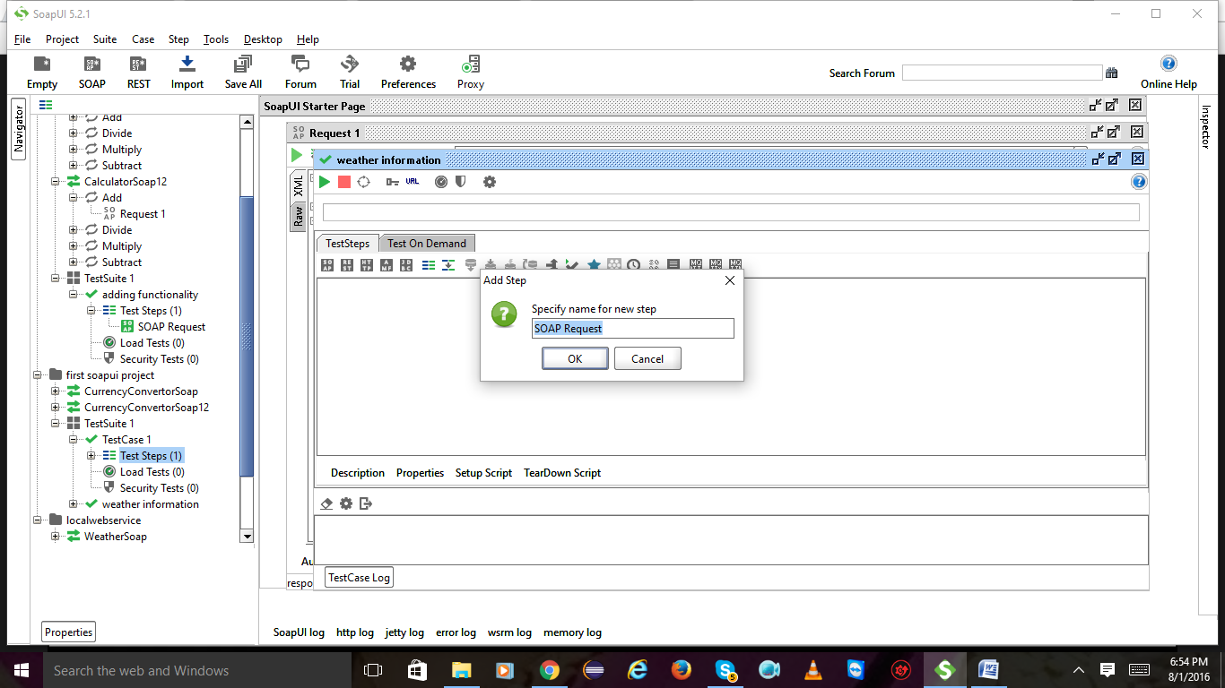

Click on ok

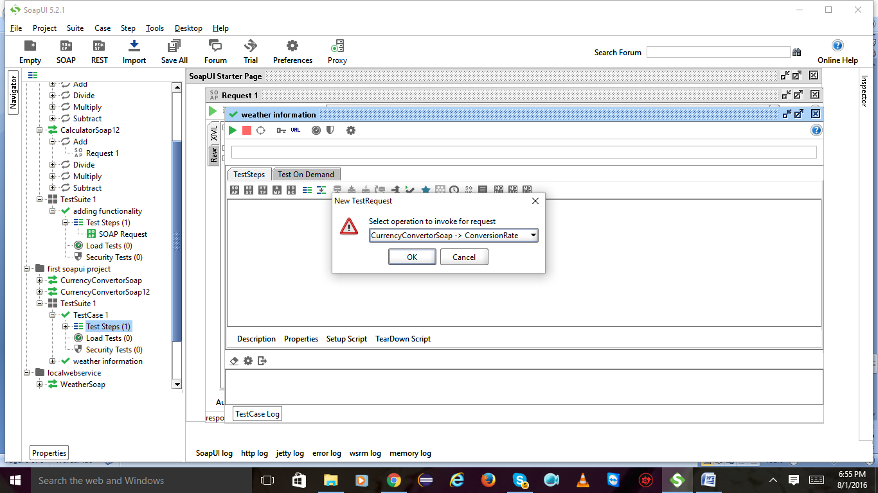

Click on ok

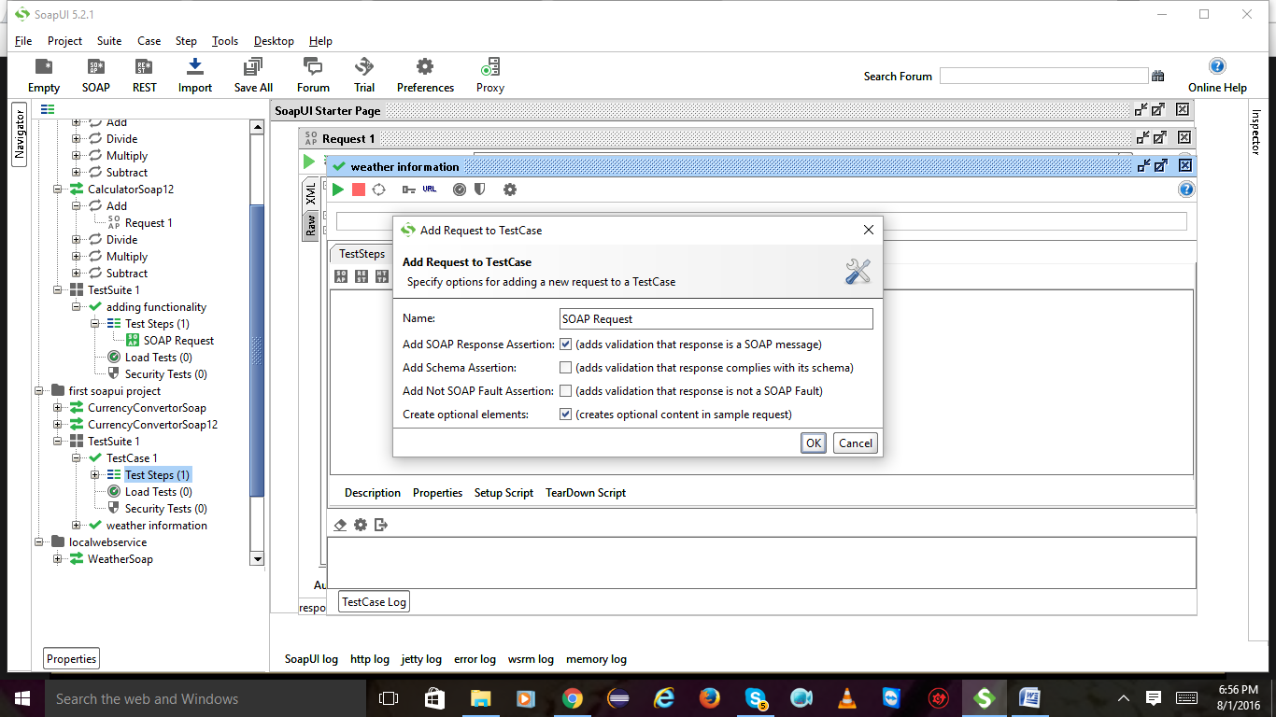

Now u will get into this page

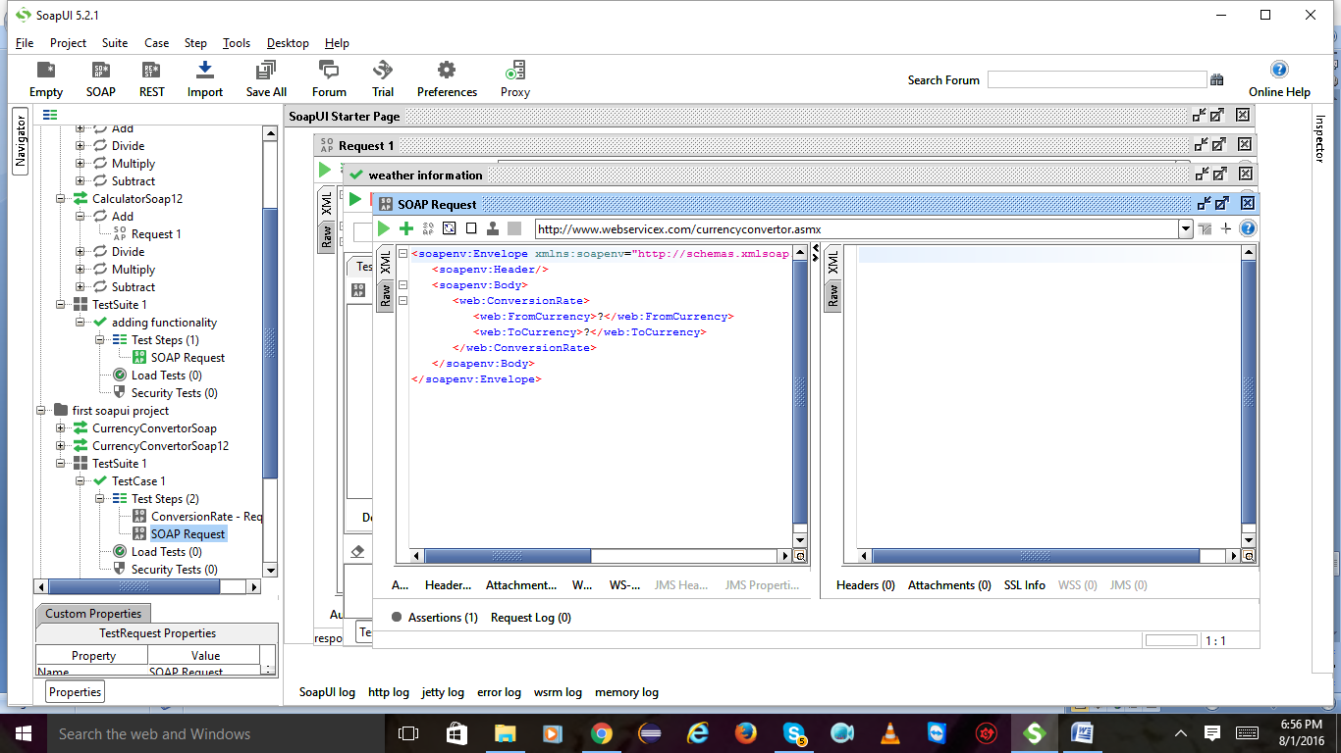

**verify response returning true:**

Give the parameters and hit on play button u will get the result on right side

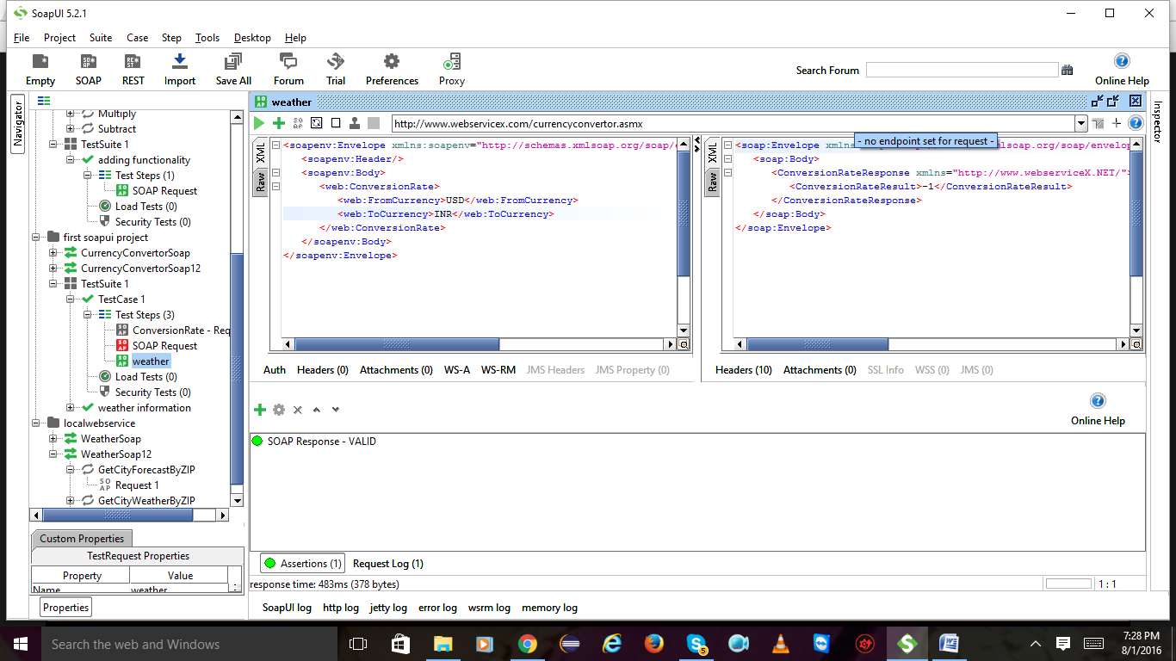

2)Click on plus symbol to add assertions and again click on contains

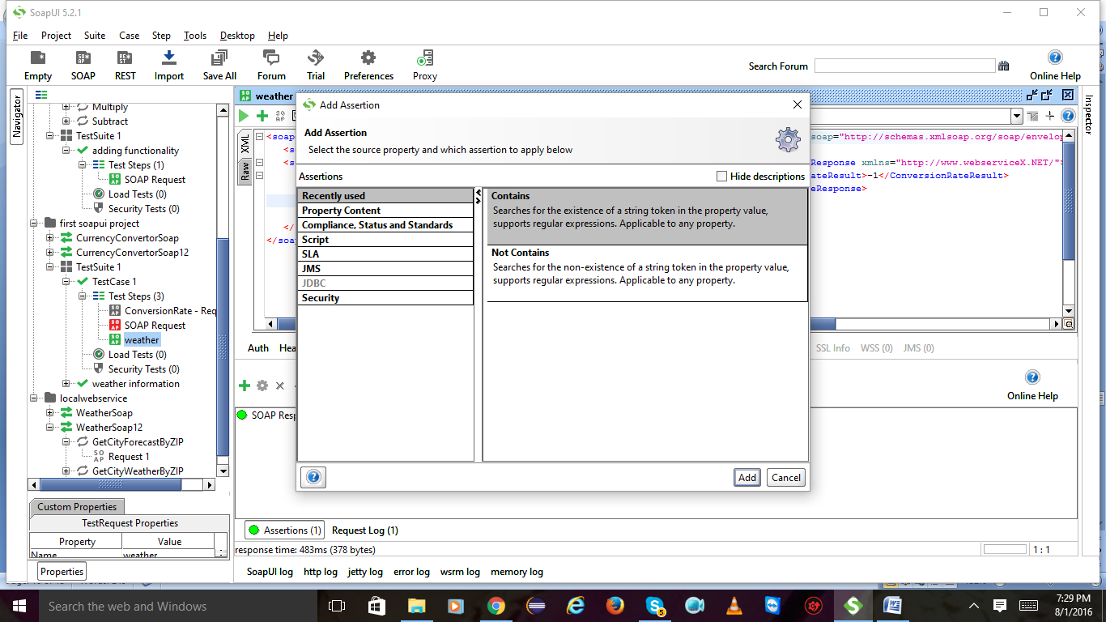

Type whatever u get in the previous result like true or false.after giving it will checks that it is matching with the previous result or not.if yes the test is successful.

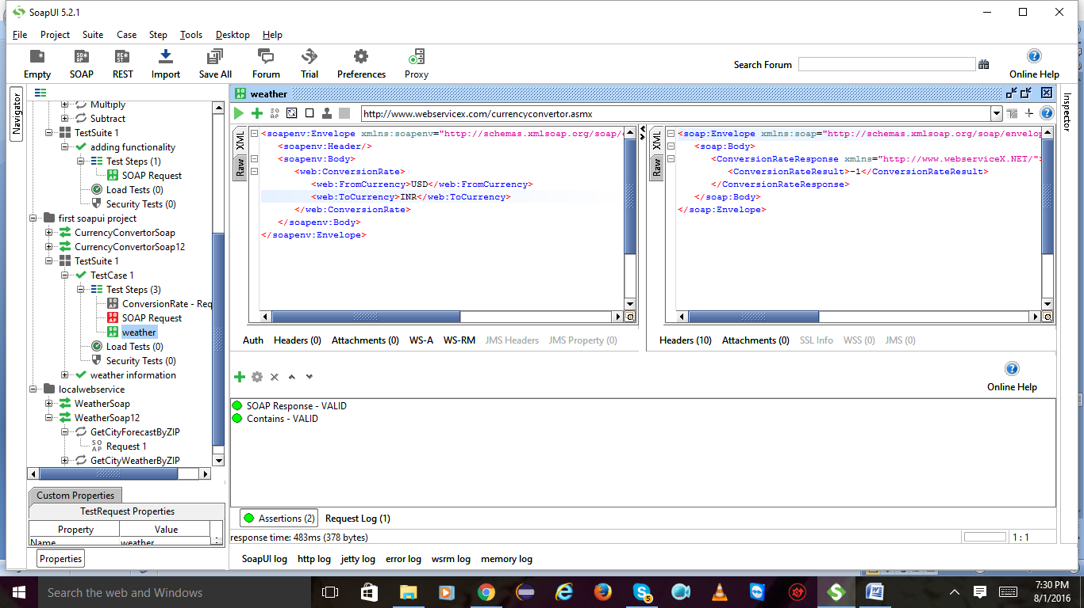

Assertion is **valid**



Add another assertion and select property content and select not contains

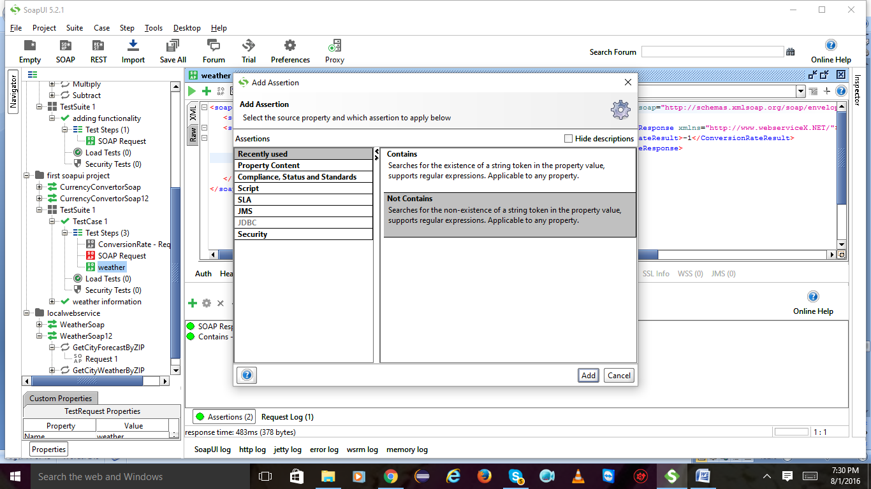

Give opposite result of previous result and click on ok

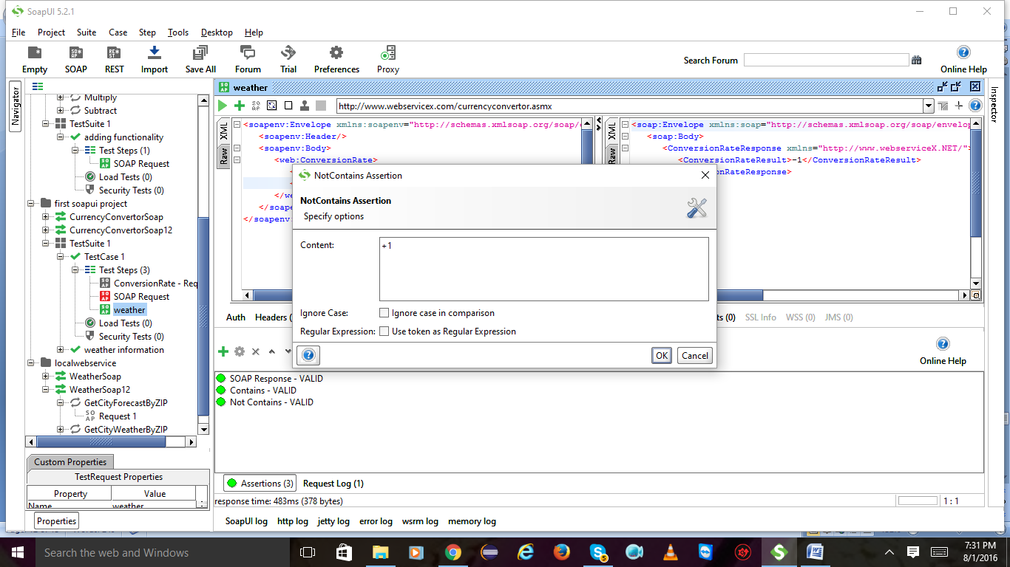

Now you will get the **not contains** assertion is **valid**

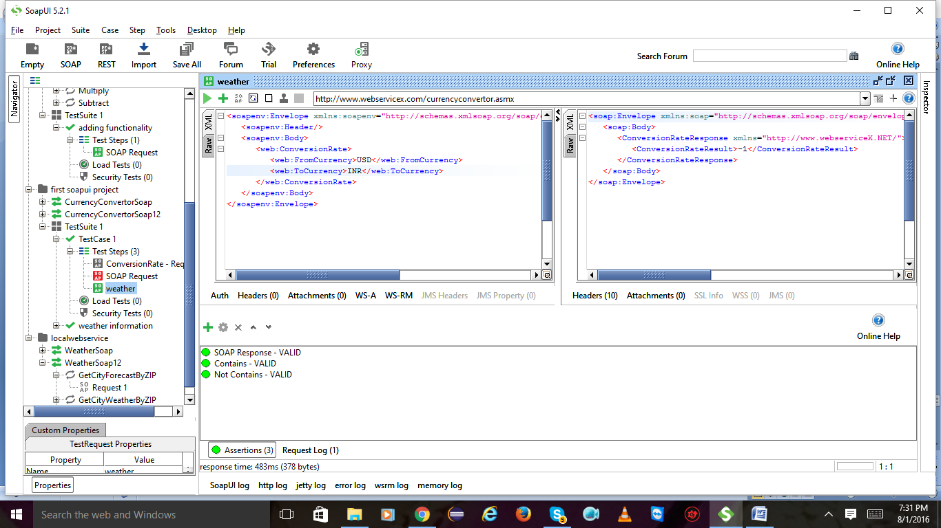

Add assertion and select compliance in that soap response double click on it

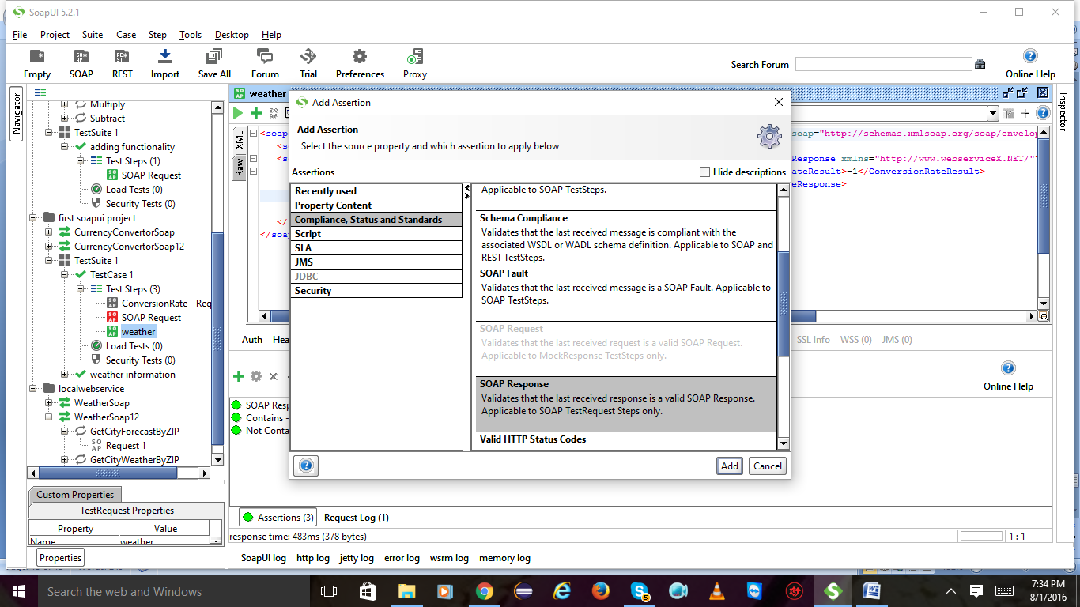

Remove soap response and add again

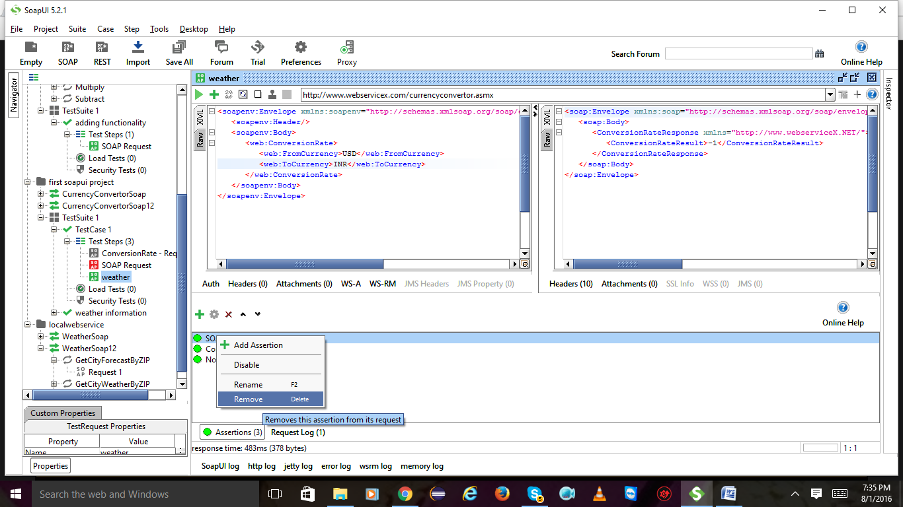

Again I have added soap response

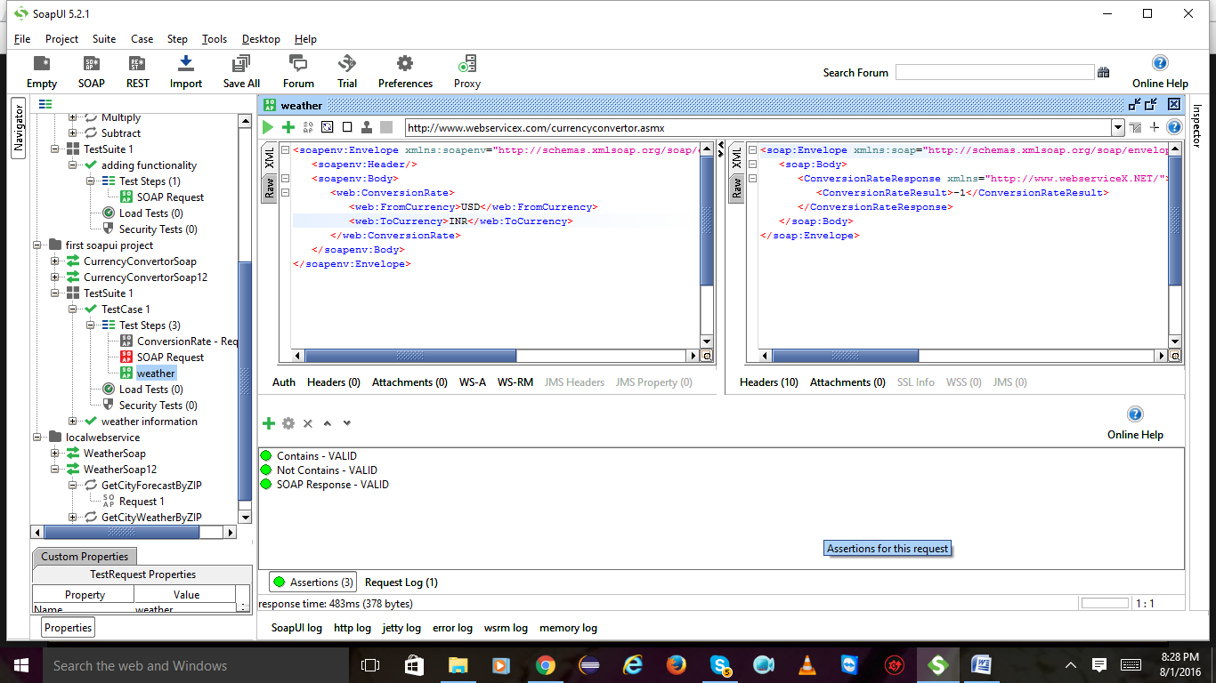

Select Valid http status

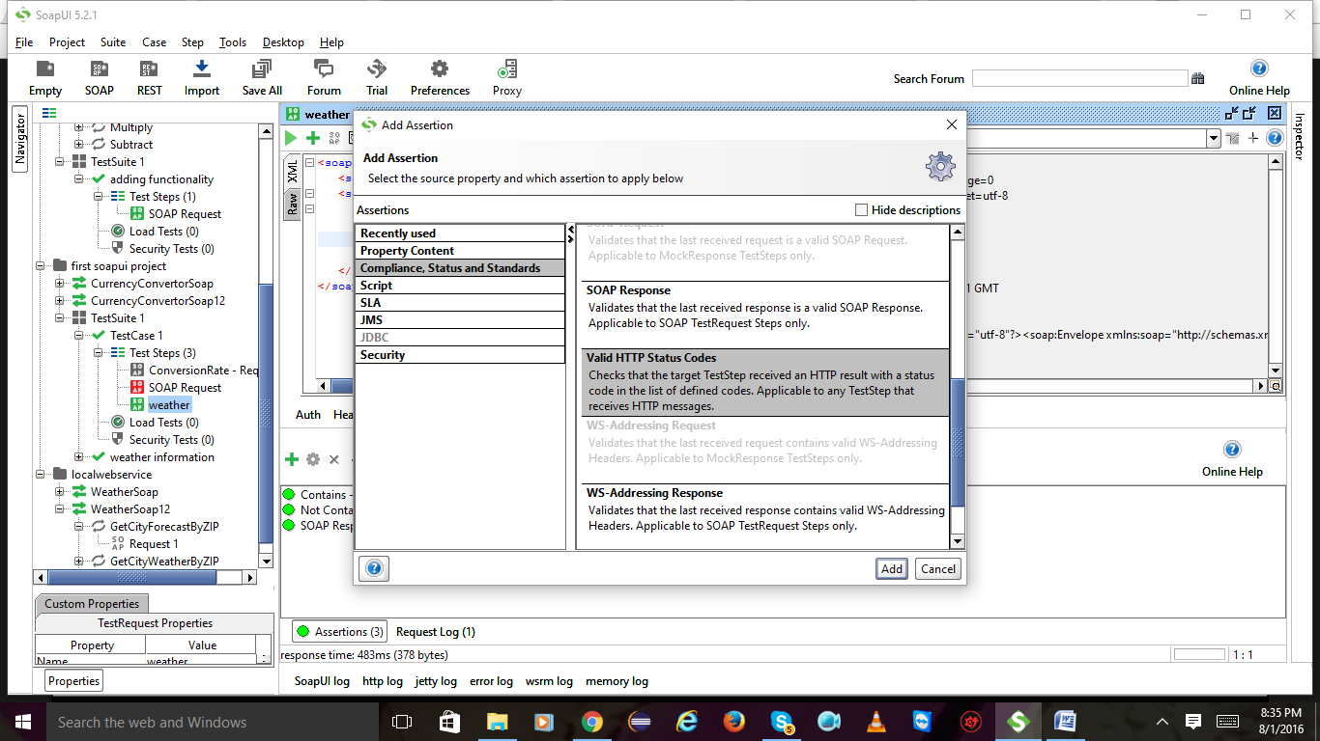

Give 200 as per the raw right side and click on ok

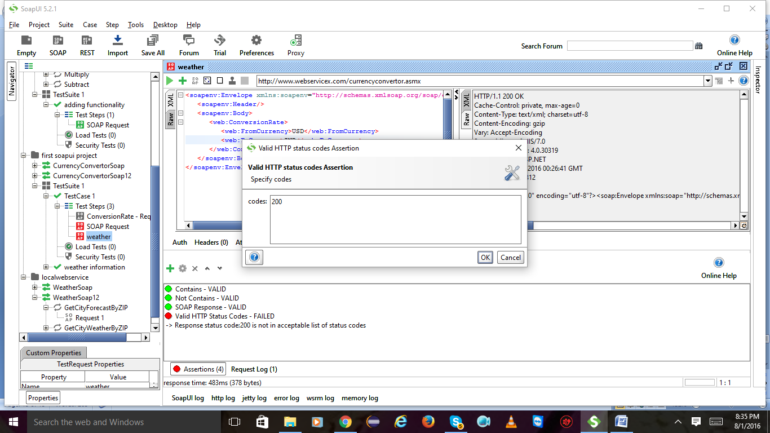

Valid http status codes is valid

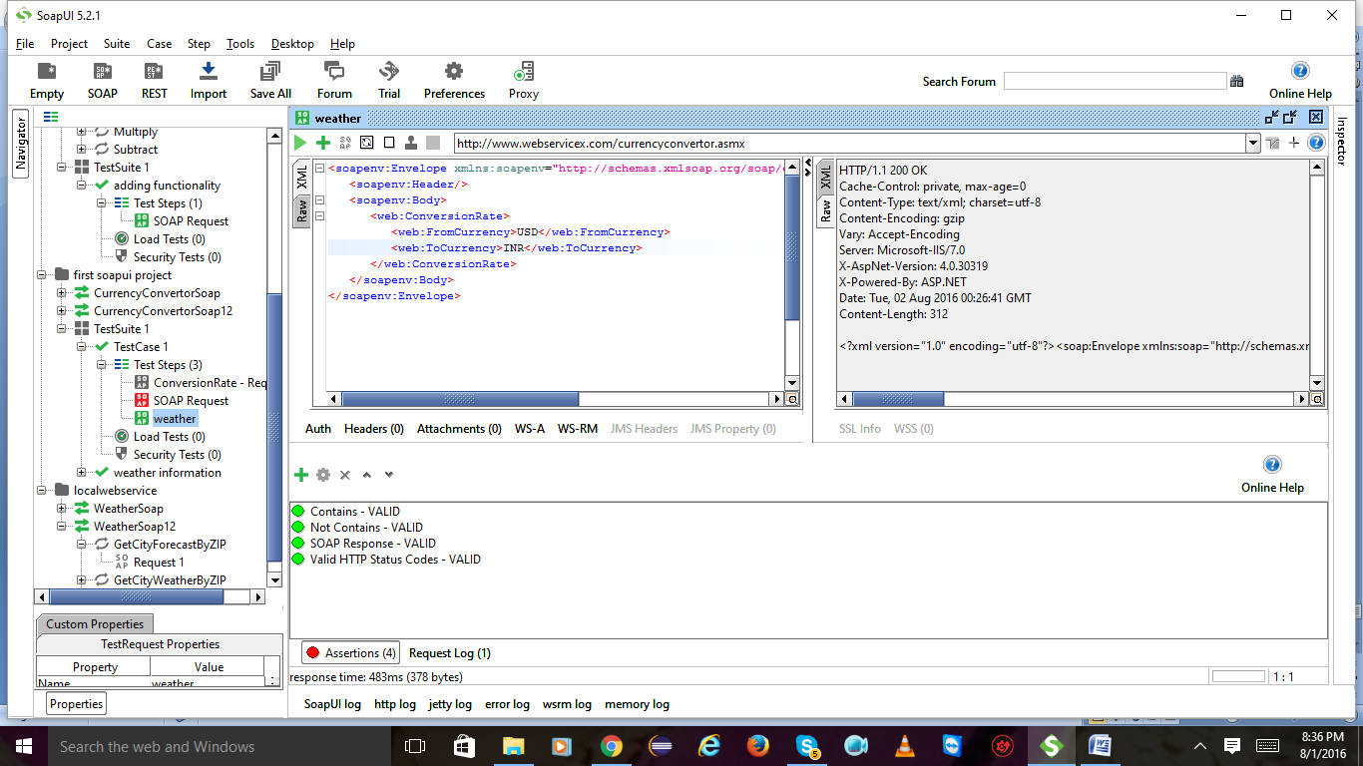

verify that response time is with in boundaries:

add assertion and select SLA in that response SLA click on ok

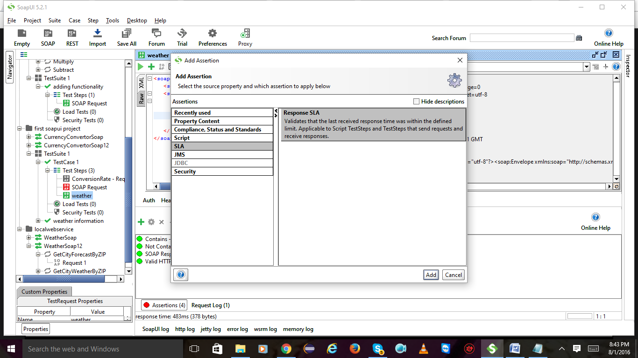

Give whatever millisec it is having

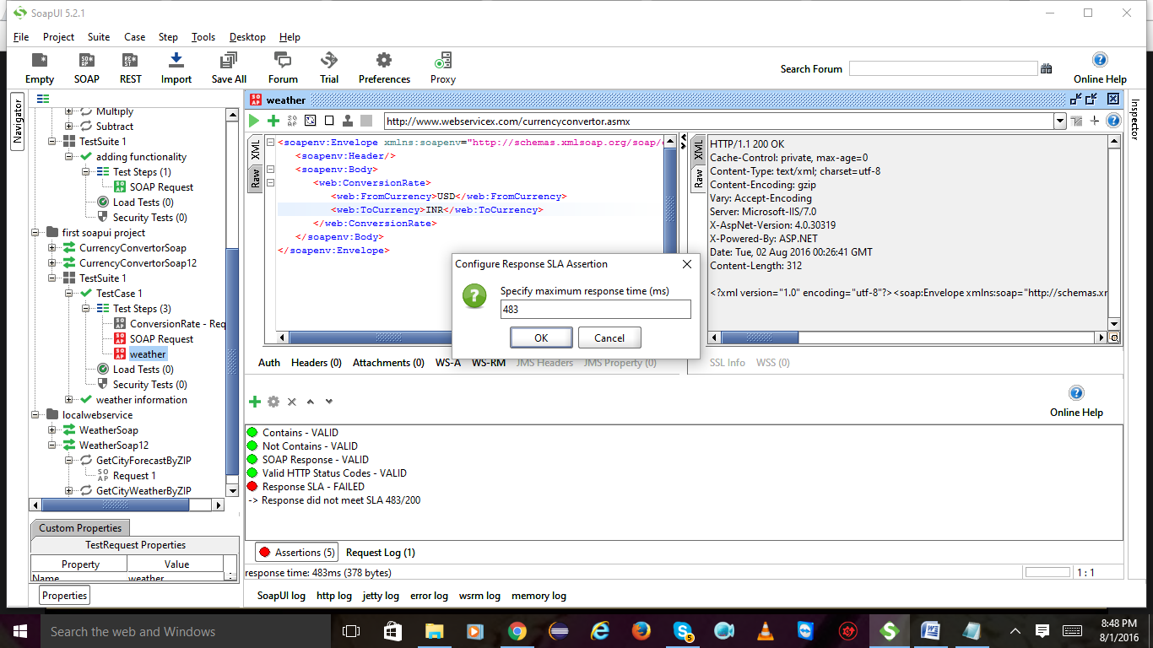

Response SLA is valid

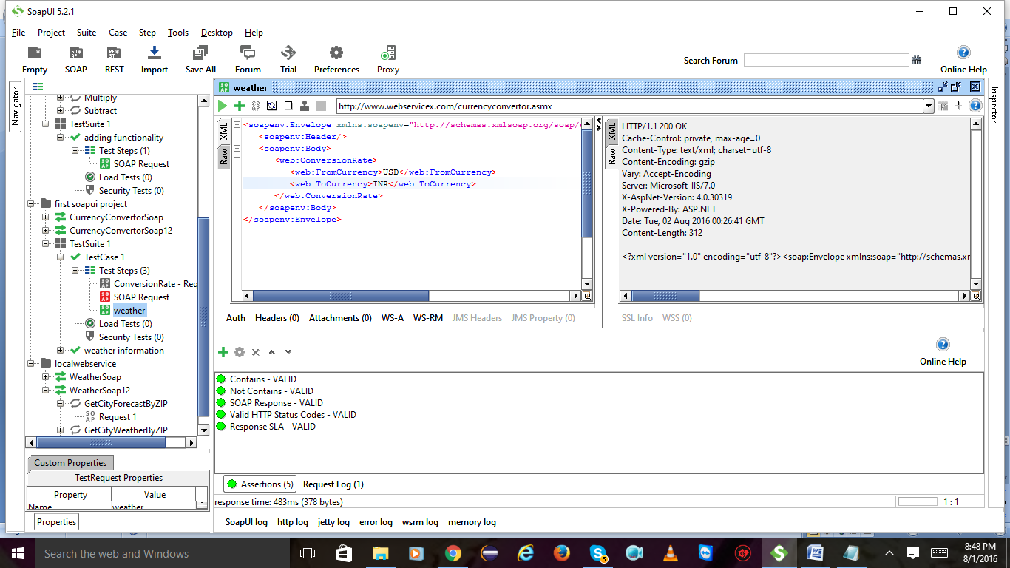

verify security threat

Add assertion select security click on add

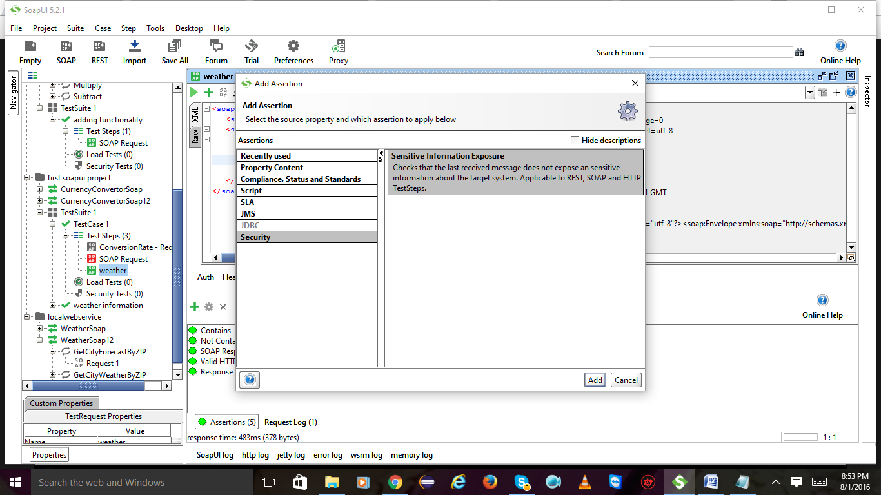

Add assertion here again

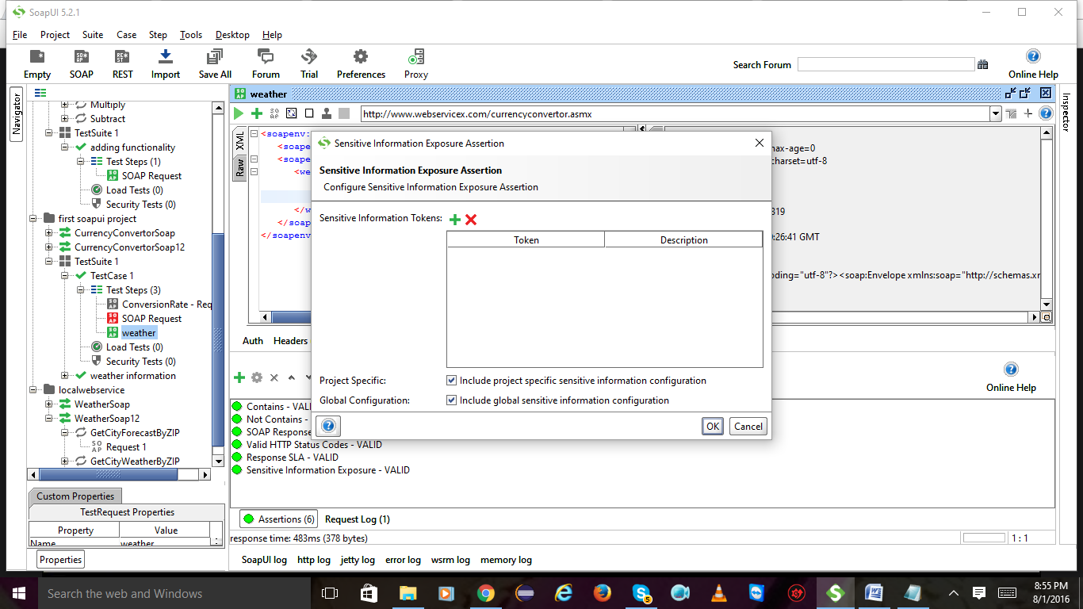

Enter token eg : random and click on ok

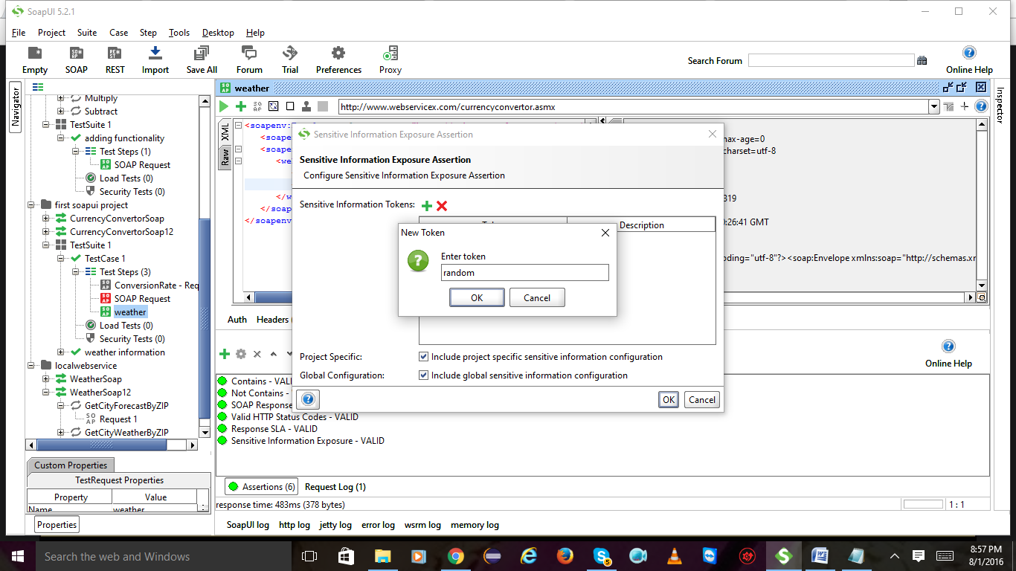

Enter description and click on ok 2 times

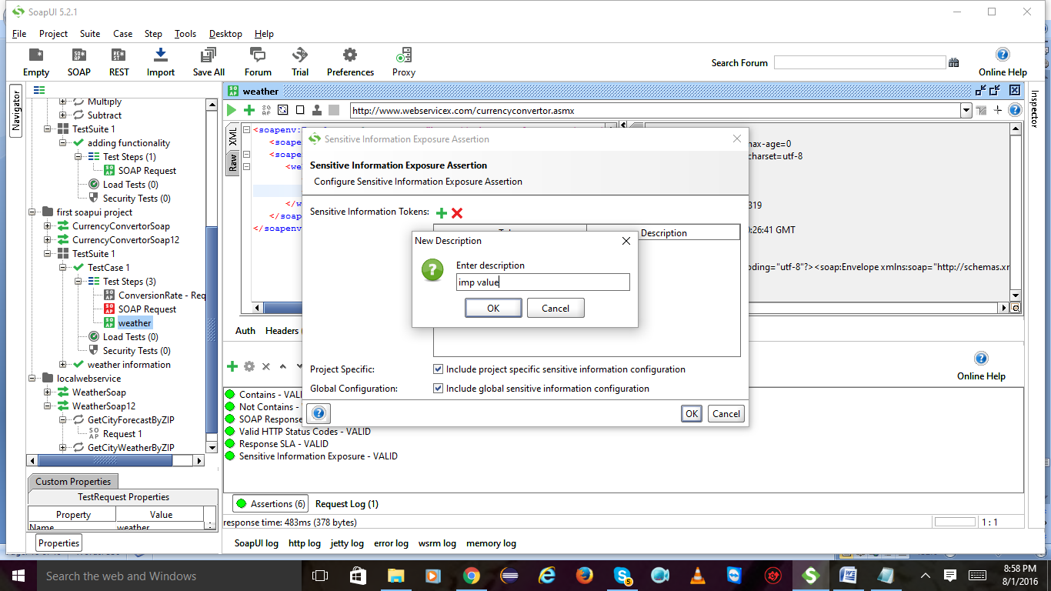

Sensitive information exposure is valid:

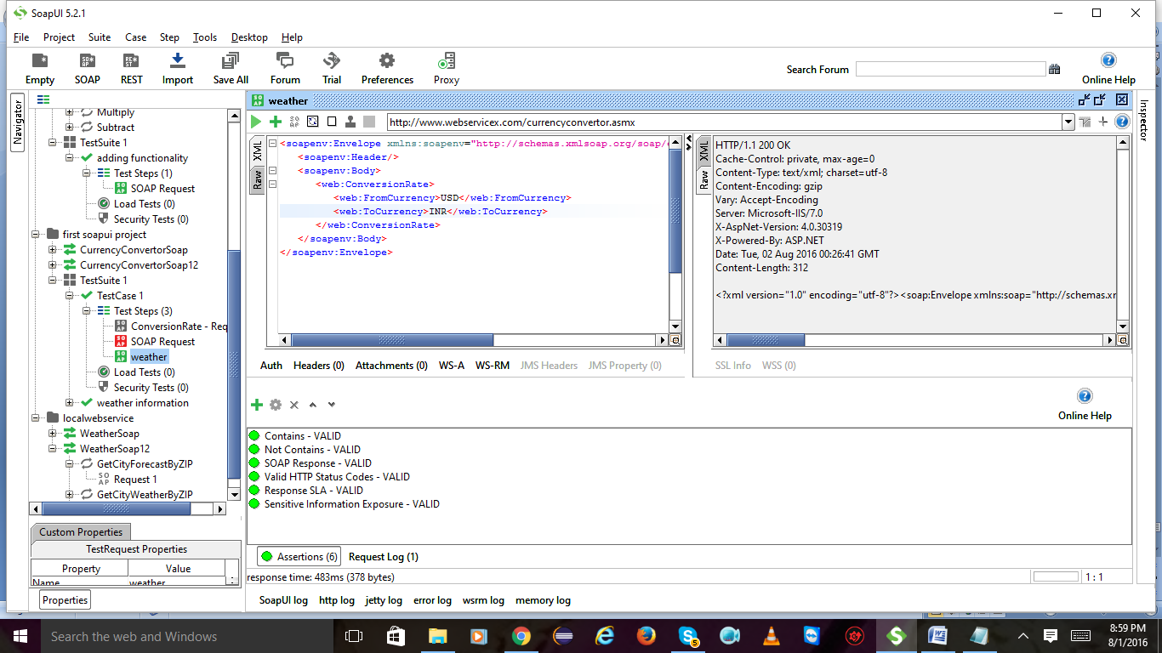

Advanced assertions:

Create a new test case:

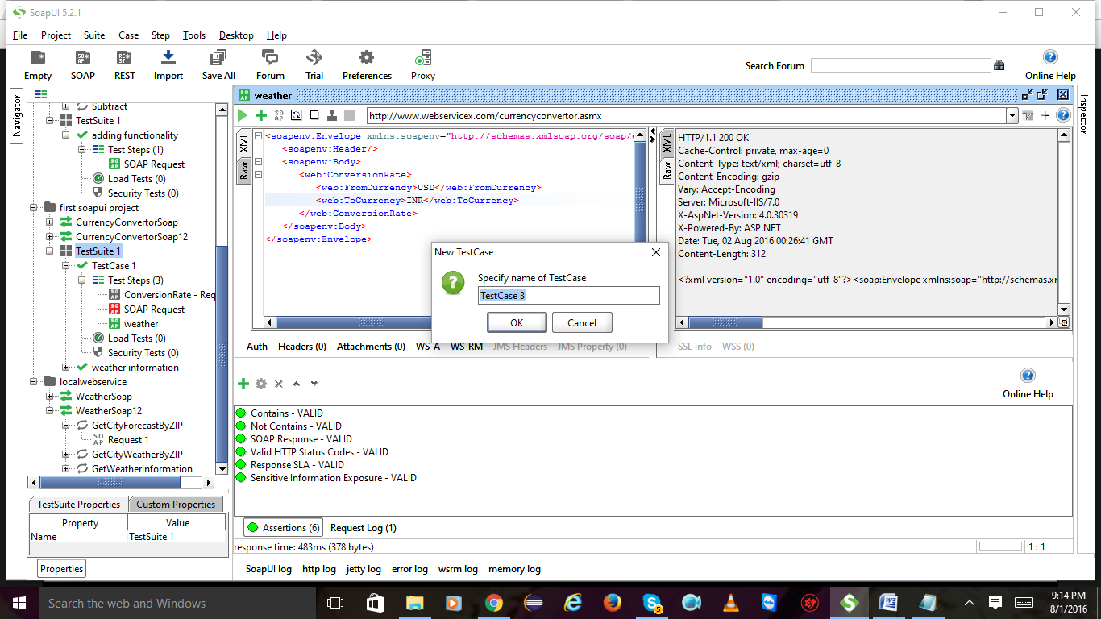

Add step and select soap request

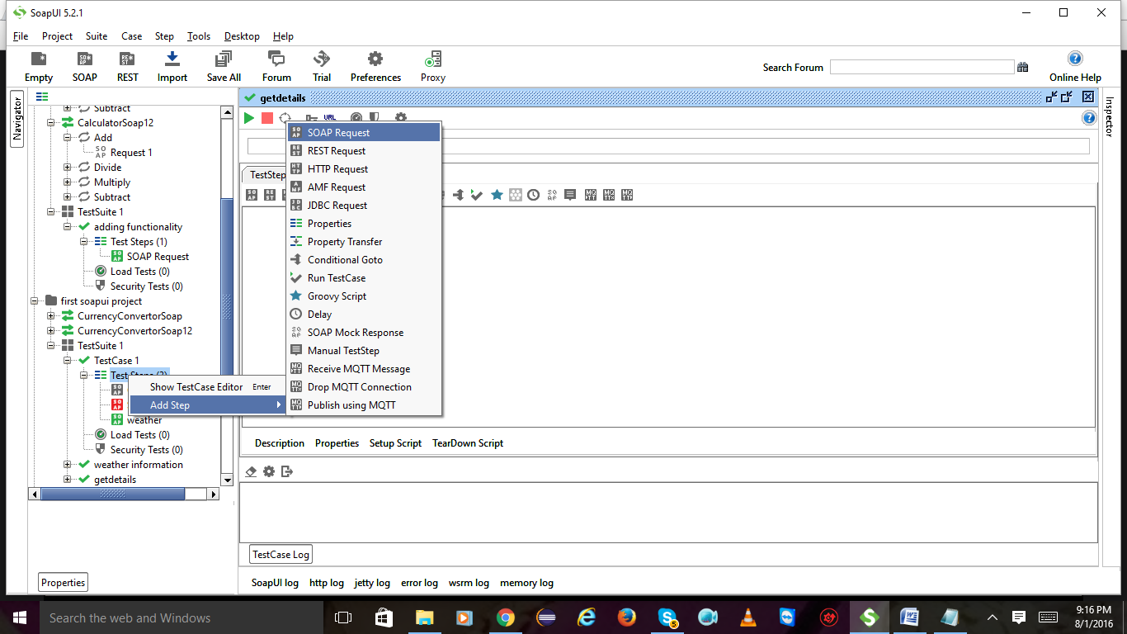

Groovy scripting:

Create a new soapui project

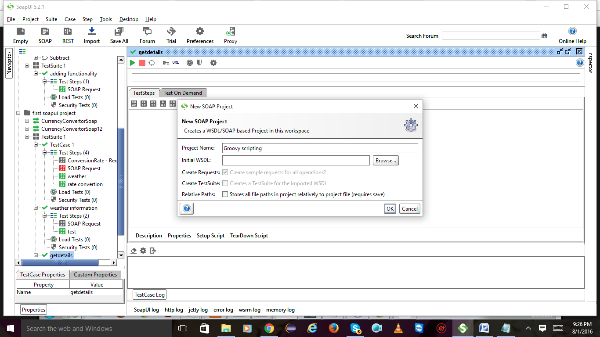

Create a test suite and click on ok

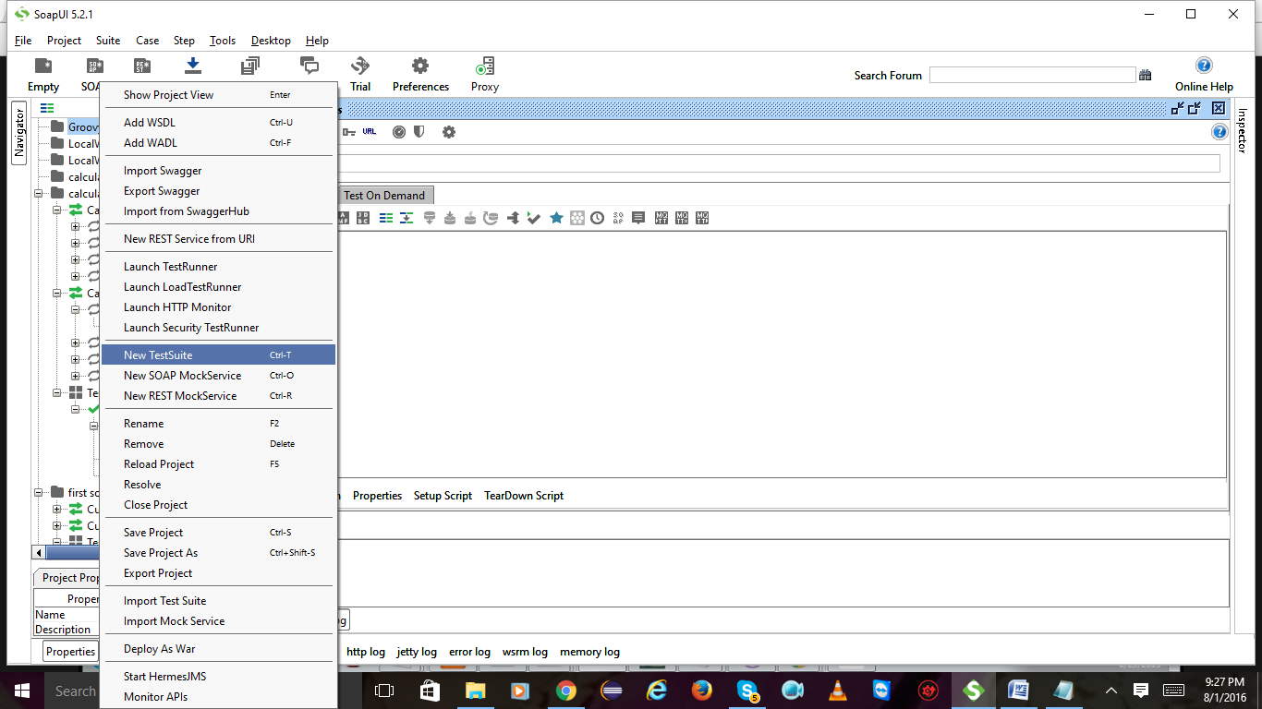

Create a test case

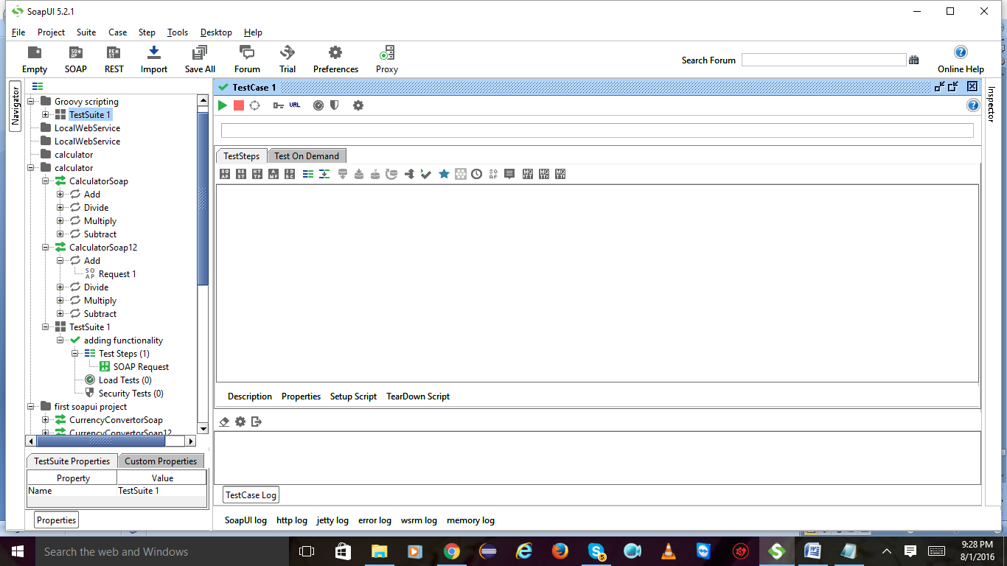

Expand test case Right click on test steps and select add step and then groovy script and click on ok

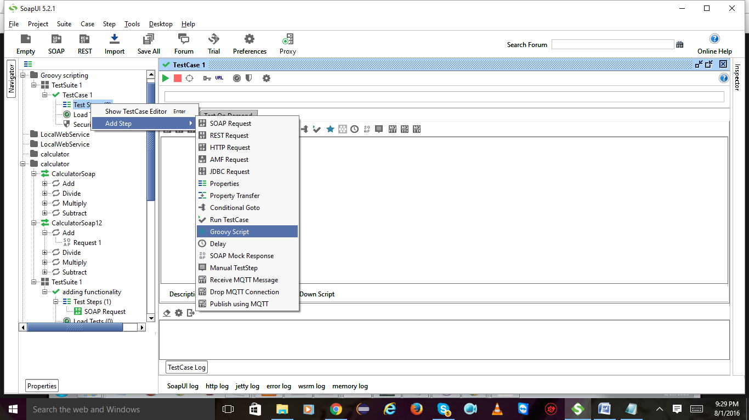

Write a script and hit on play button u will see the result below

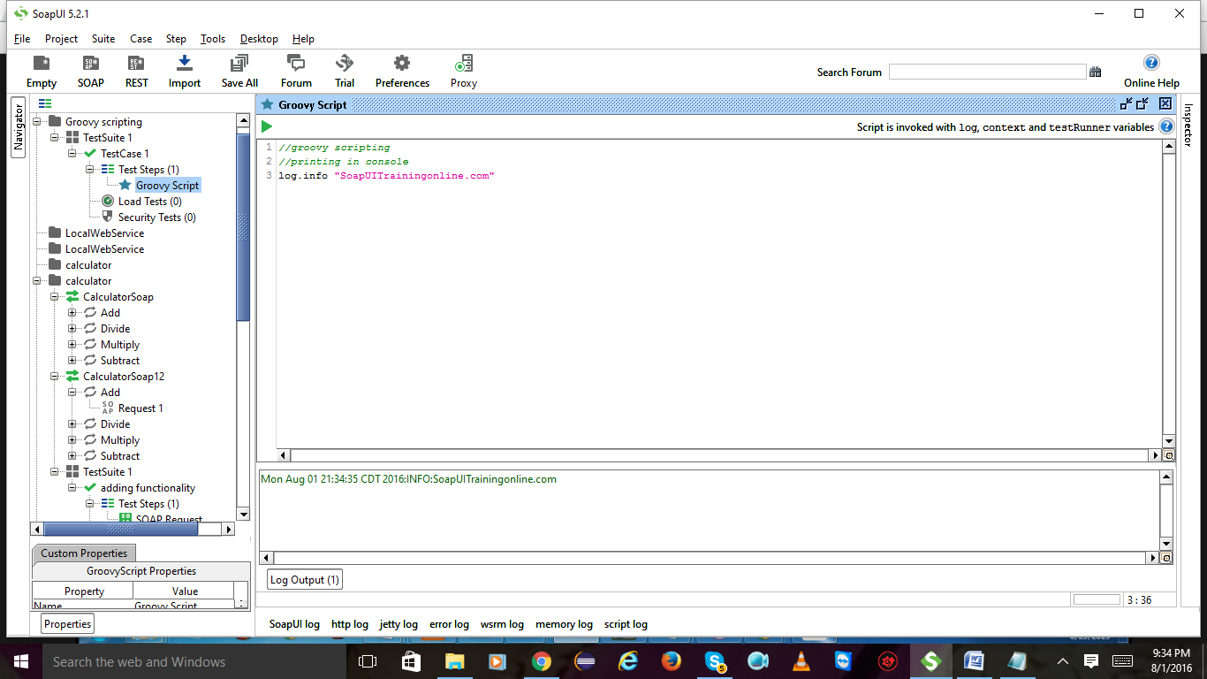

Declaration:

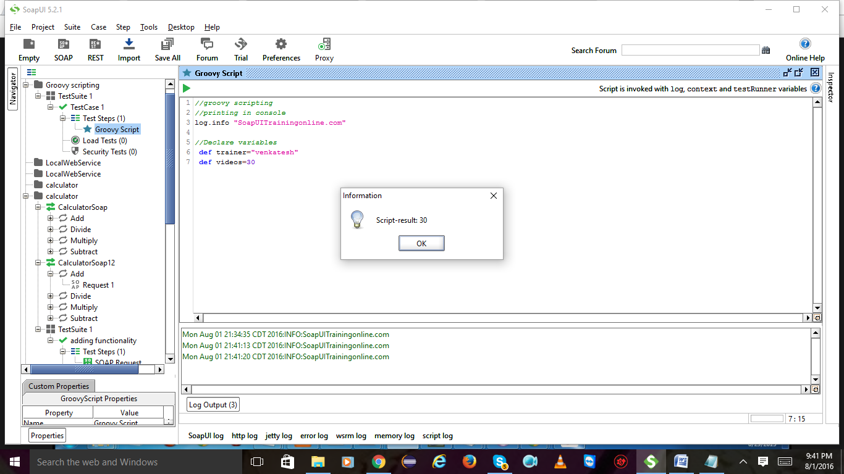

After declaring lets write some code to get the data

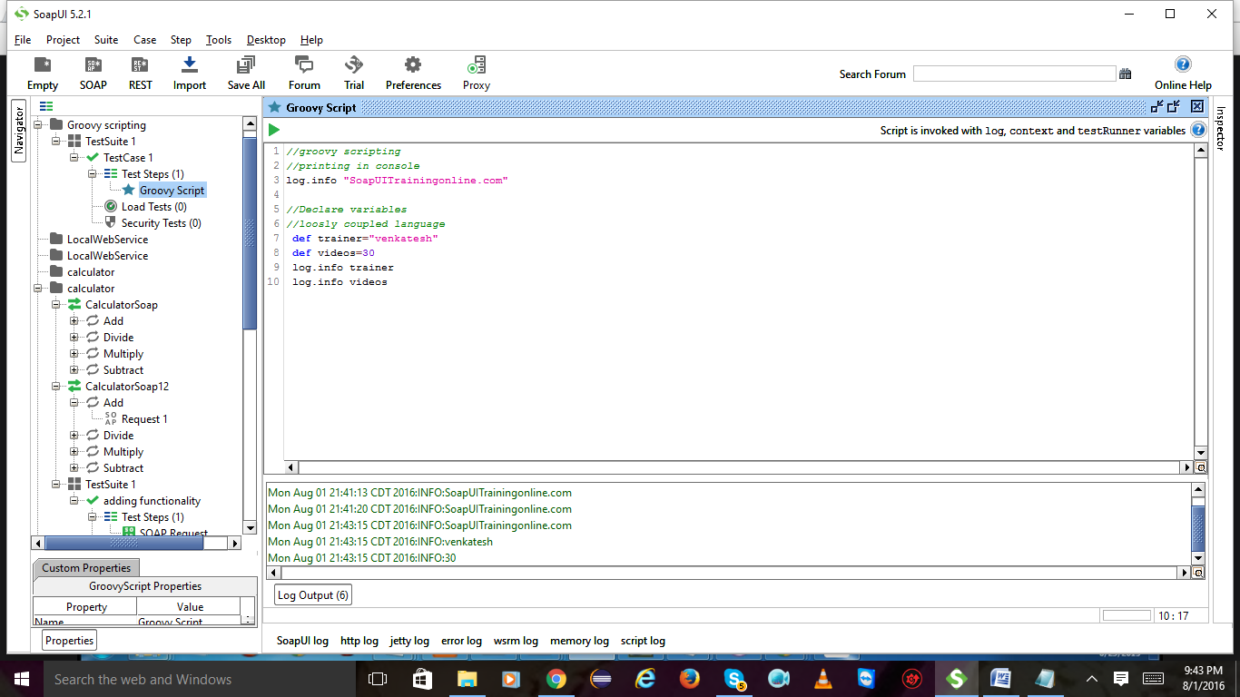

We are concatenating the no of videos

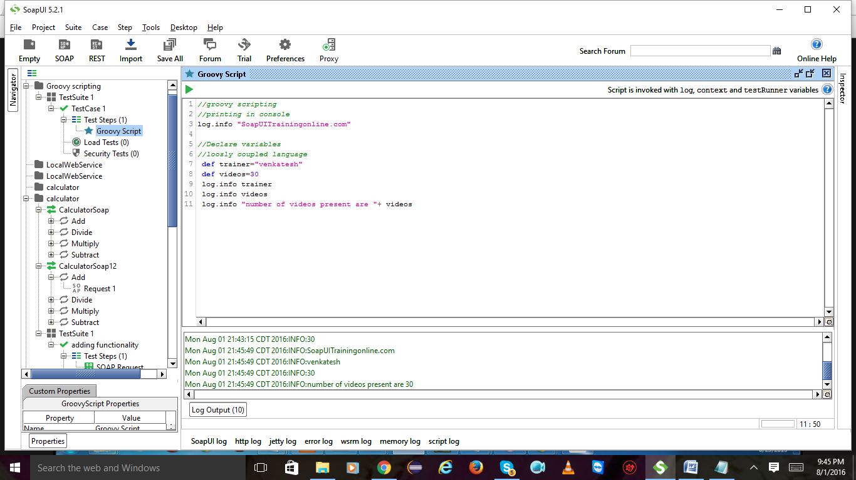

**JSON and XML:**

**JSON: It is written using brackets, parenthesis etc..**

**XML: It is written using opening and closing tags.**

**JSON: includes arrays to describe the data**

**XML: it does not include arrays to describe the data**

**JSON example:**

**{**

**“subject”: Webservices,**

**“name”: “Neelima”,**

**“duration”: “Month”**

**“fee”: 2000**

**}**

**XML example:**

**<course>**

**<subject> Webservices </subject>**

**<name> Neelima </name>**

**<duration> Month </duration>**

**<fee> 2000 </fee>**

**</course>**